**ACKNOWLEDGEMENT**

I would like to take this opportunity to express my gratitude to the people that have been part of my journey to complete this study.

To my adviser, Dr. Khatalyn E. Mata, for providing guidance on my research. Her insights, patience and encouragement helped complete the various requirements of the study.

To the members of the panel, Prof. Edgardo S. Dajao and Dr. Dan Michael A. Cortez, for their constructive comments and suggestions which made this study relevant and concrete. To panel chairman, Prof. Manuel L. Ocampo, for being the relentless force of support for my study. I am truly thankful for his unyielding belief that I can accomplish this feat.

To Ms. Lydia de Leon and Ms. Rose Lopez, the staff of CET-GP, Director Joseph Berlin P. Juanzon and Dean Juan C. Tallara for their support to assist my research needs.

To Dr. Ryan Joseph Magtibay and Mr. Cedric Villapando, for helping in my information gathering activities and sharing their technical knowledge.

To my parents and extended family, for expressing their support and believing that I can finish this endeavor.

To my partner, Joane Marie Llamera, for pushing me to the limits and always keeping me grounded when pressure starts to settle. It was your steadfast confidence in me that kept me motivated throughout the entire study.

Lastly, I dedicate this study to my late grandmother, Geralda Lineses. Your memories never fail to make me smile. I hope I made you proud.

**ABSTRACT**

Filipinos were compelled to obtain vaccination certificates as evidence of their protection from coronavirus disease (COVID-19). The current processes to handle this varies per Local Government but majority are still manual, prone to tampering and time-consuming for medical workers. This study aims to develop a web application for vaccine certificate management. It utilized concepts of Blockchain and Merkle Tree to secure transactions and files generated from the process. The transactions were stored on a Proof-of-Authority blockchain and files were managed using InterPlanetary File Storage. These two frameworks were combined to increase data security given their native implementations of hashing and immutability. Also, it employed QR Code technology to increase ease-of-use when collecting and validating vaccine data. Face-to-face interviews with medical personnel were conducted to gather pertinent data. The application's security was assessed by using various tests from Smart Contract Weakness Classification Registry and National Institute of Standards and Technology - Cybersecurity Framework. The study's conclusions include limitations and suggestions for further research.

# **TABLE OF CONTENTS**

TABLE OF CONTENTS i

LIST OF FIGURES ii

LIST OF TABLES iv

INTRODUCTION 1

1.1 Background of the Study 1

1.2 Statement Problem 2

1.3 Objectives of the Study 3

1.4 Scope and Limitations 3

1.5 Significance of the Study 4

1.6 Definition of Terms 4

REVIEW OF RELATED LITERATURE 8

2.1 Literature Mapping 8

2.2 Related Literature 10

THEORETICAL FRAMEWORK 23

METHODOLOGY 34

4.1 Requirements Modeling 34

4.2 Quick Design 36

RESULTS AND DISCUSSION 54

5.1 Functionalities of the System 54

5.2 Implementation of Proof of Authority and Keccak Hash 60

5.3 Implementation of Merkle DAG 69

5.4 Data Tampering Results 73

5.5 Security Assessment 75

5.6 Performance Test 81

CONCLUSIONS AND RECOMMENDATIONS 83

REFERENCES 85

APPENDICES 89

# **LIST OF FIGURES**

Figure 1 - Literature Map 8

Figure 2 - Hashing Process 23

Figure 3 - Generic Blockchain Transactions 25

Figure 4 - Clique PoA Block Creation Process 26

Figure 5 - Merkle Tree Implementation using Hashes 28

Figure 6 - DAG Illustration 29

Figure 7 - Merkle DAG Implemented on a File System 30

Figure 8 - Diagram of Proposed Solution 32

Figure 9 - Conceptual Framework 32

Figure 10 - Prototype Model Phases and Process 34

Figure 11 - Context Diagram 37

Figure 12 - Data Flow Diagram 38

Figure 13 - Use Case Diagram 39

Figure 14 - Patient Registration Flowchart 40

Figure 15 - Vaccine Record Creation Flowchart 41

Figure 16 - Verify Vaccine Certificate File 42

Figure 17 - Verify Vaccine QR Code 43

Figure 18 - High-Level System Design Diagram 45

Figure 19 - System Architecture Diagram 46

Figure 20 - Blockchain Data and Function Mapping 47

Figure 21 - Relational Database Diagram 48

Figure 22 - Transactional Operation Diagram 49

Figure 23 - File Storage in Blockchain and IPFS Flowchart 50

Figure 24 - File Retrieval Flowchart 51

Figure 25 - Validate File from Blockchain Flowchart 52

Figure 26 - Validate QR Code from Blockchain Flowchart 53

Figure 27 - Patient Registration Screen 55

Figure 28 - Patient Login Screen 55

Figure 29 - Patient Home Screen (Upper Section) 56

Figure 30 - Patient Home Screen (Lower Section) 57

Figure 31 - Vaccine Record Creation Screen 58

Figure 32 - File Validation (Successful) 58

Figure 33 - File Validation (Failure) 59

Figure 34 - Scan Summary QR Code Screen 59

Figure 35 - Node Blockchain Logs for File Upload 64

Figure 36 - Detected Metamask Address of Log Sender 64

Figure 37 - Metamask account details of vaccine file uploader 64

Figure 38 - Metamask Notification of File Upload Transaction 65

Figure 39 - Merkle DAG representing sample records 70

Figure 40 - Encrypted file in IPFS 71

Figure 41 - Content Identifier Breakdown using IPFS CID Explorer 72

Figure 42 - Merkle DAG Illustration using IPFS DAG Visualizer 73

Figure 43 - UI Screenshot for invalid Summary QR Code 74

Figure 44 - Original File for Tamper Test 74

Figure 45 - Tampered File for Tamper Test 74

Figure 46 - UI Screenshot for Invalid File 75

# **LIST OF TABLES**

Table 1 - Keccak Parameters Per Length 31

Table 2 - Frontend Specifications 44

Table 3 - Backend Specifications 44

Table 4 - Blockchain Specifications 44

Table 5 - Functionality of the System 54

Table 6 - Generated Hash Value for Sample Record #1 70

Table 7 - Generated Hash Value for Sample Record #2 70

Table 8 - Securify Scan Result Details 76

Table 9 - Securify Results Summary 77

Table 10 - Slither Scan Result Details 78

Table 11 - Slither Results Summary 78

Table 12 - NIST-CF Maintenance Area Matrix 79

Table 13 - NIST-CF Data Security Area Matrix 79

Table 14 - NIST-CF Protective Technology Area Matrix 80

Table 15 - Create Vaccine Record Load Test Result 81

Table 16 - Validate Vaccine QR Code Load Test Result 81

Table 17 - Validate Vaccine File Load Test Result 82

**Chapter One**

# **INTRODUCTION**

## **1.1 Background of the Study**

With the advancement of computer technology, electronic documentation and the use of electronic medical records have become more feasible. Medical records on a shared computer network that are read and written electronically on a relational database using a graphic user interface are referred to as electronic medical records. In the study of Tsai and Bond (2007), the authors looked at three mental health facilities that had recently switched from paper to electronic medical records. Electronic records' documentation was shown to be more thorough and retrievable than paper records. As per the study, this finding can be a factor to take in when making treatment decisions.

The work of Khalifa (2008) pointed out six ways Electronic Medical Records (EMR) could enable data accessibility and care organization: improving access to data during patient encounters, improving processes workflow, managing information overflow to clinicians, enhancing medical decision-making process care plans, supporting operational processes and improving financial data accessibility. He also emphasized that when a computer was used to retrieve patient information, physicians earned higher overall patient satisfaction rates, and when a computer was used to enter patient information, physicians received identical satisfaction rates.

The current technological advancements in the Philippines has yet to be manifested in its healthcare system. Though there were efforts from the government to adopt various modern tools, we are still miles behind other countries. The study of Ebardo and Celis (2019) identified barriers such as weak infrastructure, technology complexity and poor interface design of applications have made it difficult for various health organization to progress. The work of Gesulga et al. (2017) determined another set of barriers to the adoption of EMRs in the Philippines namely: User resistance, lack of education and training, and concerns arising from data security. In the paper of Ebardo and Tuazon (2019), the authors discussed how the integration of existing information systems to be “paper-less” can produce potential savings. This is crucial given that the Philippines is still a developing country and has budget constraints to health systems.

The current pandemic situation poses another scenario for the state of EMRs in the country. Government has boosted efforts in immunizing majority of the population. Local Government Units (LGUs) had implemented varying strategies to keep proof and records of vaccinations. Areas in the National Capital Region (NCR) have setup online web application to accommodate the vaccination process. Specifically, the city of Manila had employed a digitized way of keeping vaccination certificates and making them downloadable to its citizens. Other cities like Quezon City and Makati have a hybrid of online and manual processes. Although NCR cities have initiated the computerized way to obtain vaccination certificates, it is worth noting that most of the province and remote still utilize the pen and paper route.

## **1.2 Statement Problem**

At present, there is no unified system being implemented in the Philippines on Vaccination Certificates. LGUs have different strategies on their issuance of vaccination certificates. Most of them issue paper-based cards while some LGUs have web applications for their constituents to access the records. Security of these records is also in question as there are reports that some people have tampered certificates for personal gains. A regional news from DILG dated December 3, 2021 warns the public on using fake vaccination documents (https://dilg.gov.ph/regional-news/DILG-R10-warns-public-Dont-fake-vaccination-cards-or-face-raps/NR-2021-1192).

## **1.3 Objectives of the Study**

This study aims to design and develop an application that integrates blockchain and InterPlanetary File System (IPFS) to ensure the integrity of vaccination data.

Specifically, the study seeks to address the following objectives:

1. To apply Proof of Authority (PoA) blockchain and Keccak Hash Algorithm in maintaining transactional records.
2. To apply hash tree concept of Merkle DAG for data storage.
3. To assess security aspects of the proposed application by using Solidity Security Audits and NIST-CSF (National Institute of Standards and Technology - Cybersecurity Framework)

## **1.4 Scope and Limitations**

The study was focused on developing an application for management of COVID-related records. Since there are privacy regulations concerning health information, the researcher used dummy data and instead probed more on the processes on how these records were archived or managed.

The study excluded vaccine management such as scheduling. Thus, it was focused on the results or outputs of these processes. The study assumed that information from the vaccine transaction were ready to be encoded in the system.

The study was only concerned on Vaccine Certificates. The researcher concentrated on developing an alternative storage system and accessibility strategy for medical units, patients and other verifying party.

## **1.5 Significance of the Study**

Results obtained from the study benefits the following stakeholders:

**Patients**. Above all, patients greatly benefit on this application. Various regulations and laws have been implemented to ensure people are not spreaders or vaccinated. Currently, there are no unified way in getting and presenting these records are proof. More so, bad actors are using this pandemic to make money out of tampering records. The application solves the woes of patients in terms on ease of access and portability of their records. They also have full autonomy of said records.

**Medical Personnel**. The application helps medical workers to focus on their medical line of duty and alleviating various admin jobs.

**Third Party Validators.** As mentioned above, records tampering has become rampant. Businesses or employers requiring such records can now be protected of this illegal activity.

## **1.6 Definition of Terms**

**Block** - A place in a blockchain where information is stored and encrypted

**Blockchain** - A digital ledger of transactions that is duplicated and distributed across the entire network of computer systems

**Blockchain Network** - A technical infrastructure that provides ledger and smart contract (chaincode) services to applications.

**Cipher Text** - A series of randomized letters and numbers which humans cannot make any sense of.

**Clique** - PoA protocol implemented in Geth

**Consensus Mechanism** - A fault-tolerant mechanism that is used in computer and blockchain systems to achieve the necessary agreement on a single data value or a single state of the network among distributed processes or multi-agent systems, such as with cryptocurrencies.

**Consensus Protocol** - Forms the backbone of blockchain by helping all the nodes in the network verify the transactions.

**Content Addressing** - A way to find data in a network using its content rather than its location.

**Content Identifier (CID)** - A label used to point to material in IPFS. It doesn't indicate where the content is stored, but it forms a kind of address based on the content itself. CIDs are short, regardless of the size of their underlying content.

**Cryptographic Hash Function** - Process that converts data of arbitrary size (commonly referred to as the "message") into a fixed-size bit array ("hash value", "hash", or "message digest")

**Cryptography** - Science of secret writing with the intention of keeping the data secret.

**Digital Envelope** - A secure electronic data container that is used to protect a message through encryption and data authentication.

**Digital Signature** - A cryptographic value that is calculated from the data and a secret key known only by the signer.

**Directed Acyclic Graph (DAG)** - It consists of vertices and edges (also called arcs), with each edge directed from one vertex to another, such that following those directions never form a closed loop.

**Distributed Hash Table (DHT)** - A decentralized data store that looks up data based on key-value pairs.

**Ethereum** - A decentralized, open-source blockchain with smart contract functionality.

**Genesis Block** - First block of a block chain.

**Geth (Go Ethereum)** - A command line interface for running Ethereum node implemented in Go Language.

**Hash Digest** - Output of the hash function.

**Hash Table** - A type of data structure that stores key-value pairs. The key is sent to a hash function that performs arithmetic operations on it.

**Hashing** - Process that calculates a fixed-size bit string value from a file.

**InterPlanetary File System (IPFS)** - A protocol and peer-to-peer network for storing and sharing data in a distributed file system.

**Keccak** - A family of hash functions that is based on the sponge construction, and hence is a sponge function family. Also known as SHA-3.

**Merkle DAG** – A DAG where each node has an identifier, and this is the result of hashing the node's contents.

**Merkle Root** - Created by hashing all the transaction hashes together in pairs — producing a unique hash for all the transactions in a block.

**Merkle Tree** - A tree in which every "leaf" (node) is labelled with the cryptographic hash of a data block, and every node that is not a leaf (called a branch, inner node, or inode) is labelled with the cryptographic hash of the labels of its child nodes.

**MetaMask** - A software cryptocurrency wallet used to interact with the Ethereum blockchain.

**Peer-to-Peer (P2P) Network** - A group of computers are linked together with equal permissions and responsibilities for processing data.

**Plain Text** - Clear, basic unencrypted string of text.

**Private Key** - Used to decrypt cipher text to plain text and only available to its owner.

**Proof-of-Authority (PoA)** - An algorithm used with blockchains that delivers comparatively fast transactions through a consensus mechanism based on identity as a stake.

**Proof-of-Work (PoW)** - Describes a system that requires a not-insignificant but feasible amount of effort in order to deter frivolous or malicious uses of computing power, such as sending spam emails or launching denial of service attacks.

**Proof-of-Stake (PoS)** - A cryptocurrency consensus mechanism that requires you to stake coins, or set them aside, to be randomly selected as a validator.

**Public Key** - Used to encrypt plain text to cipher text and available to anyone accessing the application.

**QR Code** - A two-dimensional version of the barcode, typically made up of black and white pixel patterns.

**Signer Nodes** - Authorized nodes in the blockchain to propose a block

**Smart Contract Weakness Classification (SWC)** - A smart contract specific software weakness classification scheme for developers, tool vendors and security practitioners.

**Smart Contracts** - Programs stored on a blockchain that run when predetermined conditions are met

**Solidity** - An object-oriented programming language for implementing smart contracts on various blockchain platforms, most notably, Ethereum.

**Sponge Function** - Any of a class of algorithms with finite internal state that take an input bit stream of any length and produce an output bit stream of any desired length.

**Chapter Two**

# **REVIEW OF RELATED LITERATURE**

## **2.1 Literature Mapping**

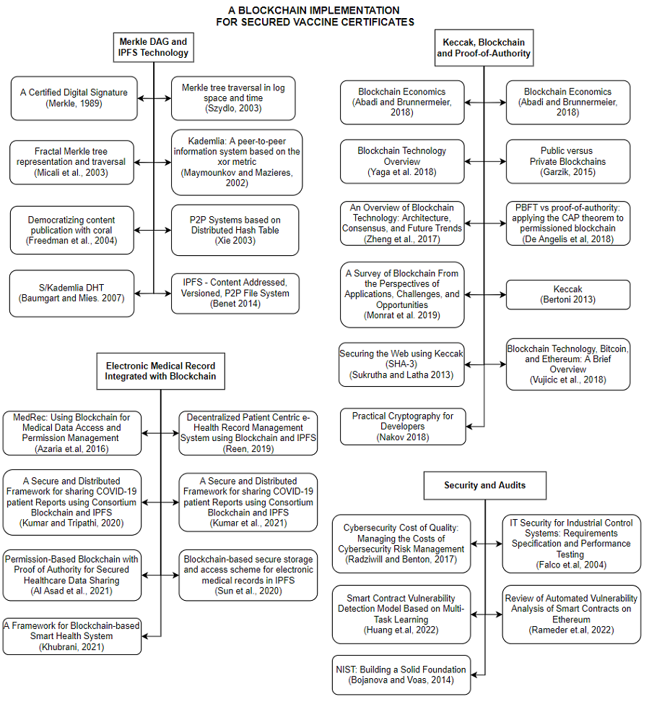

Figure - Literature Map

Figure 1 illustrates how related literature were grouped and mapped. The researcher clustered the items into 4 main divisions:

1. Merkle DAG and IPFS

2. Keccak, Blockchain and Proof-of-Authority

3. Electronic Medical Record Integrated with Blockchain

4. Security and Audits

Group 1 starts with studies focused on theoretical discussion of Merkle Tree algorithm as proposed by Ralph Merkle. Next are variations and iterations of the tree such as Fractal Merkle Tree. It then mentions studies about its applications to real-life problems such as decentralized web applications, peer-to-peer systems and file storage.

Group 2 deals with Blockchain. Its concept is based upon theories of hashing and immutability. With this, the researcher included literature and studies about Keccak as this was the hashing algorithm used by the consensus used on the proposed application. Studies about comparison of blockchain consensus and performance were listed as basis in choosing the consensus. Lastly, Proof-of-Authority literature were included to discuss its theoretical and technical aspects.

Group 3 is about the various studies about integration of blockchain to Electronic Medical Records. The researcher gathered different studies that used various combination of technologies such as centralized database, cloud and blockchain. It highlights the strengths and weaknesses of each integration. The researcher also noted the author’s suggestion based from their studies.

Group 4 discusses the security audits and frameworks used to assess the proposed application. It mainly dwells on two frameworks: Smart Contract Weakness Classification Registry and National Institute of Standards and Technology - Cybersecurity Framework.

## **2.2 Related Literature**

**Merkle Tree**

In 1989, Ralph Merkle introduced the Merkle tree in his paper. It is a tree constructed bottom-up. More precisely, the tree discussed in this paper is a full binary tree and constructed from the bottom-up. Assume that the height of the tree is *hm*, and the tree owns 2hm data blocks *xi* and *yi=hash(xi),i∈[0,2hm−1]*, where *yi* is a leaf node value of the Merkle tree. Each value of the parent node is the hash of the concatenation of its children, *yparent=hash(yleft|yright)*, where | refers to concatenation. Below is a pseudocode format of the Classic Merkle Tree Traversal algorithm:

1. Set *leaf* = 0.

2. Output:

• Compute and output *leaf* with *LEAFCALC(leaf)*

• For each *h* ∈ [0,*H* − 1] output {*authh*}.

3. Refresh Auth Nodes:

For h such that 2h divides leaf + 1:

• Set authh be the sole node value in stackh.

• Set *startnode* = (*leaf* + 1 + 2h) ⊕ 2h.

• *stackh.initialize(startnode,h)*.

4. Build Stacks:

For all *h* ∈ [0,H − 1]:

• stackh.update(2).

5. Loop

• Set *leaf* = *leaf* + 1.

• If *leaf* < 2*H* go to Step 2

A Logarithmic Merkle Tree Traversal was proposed by M. Szydlo (2003). The main idea of the improved algorithm is, to reduce the memory requirements, by reducing the number of active treehash instances during the signature generation.. Here is the pseudocode:

1. Set *leaf* = 0.

2. Output:

• Compute and output leaf with *LEAFCALC*(*leaf*)

• For each *h* ∈ [0,*H* − 1] output {*authh*}.

3. Refresh Auth Nodes:

For *h* such that 2*h* divides *leaf* + 1:

• Set *authh* be the sole node value in *stackh*.

• Set *startnode* = (*leaf* + 1 + 2*h*) ⊕ 2*h*.

• *stackh.initialize(startnode,h).*

4. Build Stacks:

Repeat the following 2*H* − 1 times:

• Let *lmin* be the minimum of {*stackh.low*} for all *h* = 0,...,*H* − 1.

• Let focus be the least *h* so that *stackh.low* = *lmin*.

• *Stackfocus.update*(1).

5. Loop

• Set *leaf* = *leaf* + 1.

• If *leaf* < 2*H* go to Step 2.

In Fractal merkle tree representation (Micali et al., 2003) and traversal, the goal is to divide the merkle tree in subtrees and to preserve and compute these subtrees, instead of single nodes. Below is the pseudocode:

1. Set *leaf* = 0.

2. Output:

• Compute and output leaf with *LEAFCALC*(*leaf*)

• For each *j* ∈ [0,*H* − 1] output {*authj*}.

3. Next Subtree:

For each *i* for which *Existi* is no longer needed, i.e., for *i* ∈ {1, 2,...,*L*} with *leaf* = 1(*mod*2*hi*):

• Set *Existi* = *Desirei*.

• Create new empty *Desirei* (if *leaf* + 2*ih* < 2*H*).

4. Grow Subtrees

For each *i* ∈ {1, 2,...,*h*}: Grow tree *Desirei* by applying 2 units to modified treehash (unless *Desirei* is completed)

5. Increase *leaf* and return back to step 2 (while *leaf* < 2*H*).

**Distributed Hash Tables**

Distributed Hash Tables (DHTs) are widely utilized to manage metadata for peer-to-peer systems. For example, the BitTorrent MainlineDHT monitors sets of peers’ part of a torrent swarm. Kademlia was introduced in a paper titled “Kademlia: A peer-to-peer information system based on the xor metric” (Maymounkov and Mazieres, 2002). It is a DHT which provides:

1. Efficient lookup through massive networks: queries on average contact dlog2(n)e nodes.

2. Low coordination overhead: it optimizes the number of control messages it sends to other nodes.

3. Resistance to various attacks by preferring long-lived nodes.

4. Wide usage in peer-to-peer applications, including Gnutella and BitTorrent, forming networks of over 20 million nodes.

In the study of Freedman et al. (2004), the authors examined Coral DSHT as an extension of Kademlia in three particularly important ways:

1. Kademlia stores values in nodes whose ids are “nearest” (using XOR-distance) to the key.

2. Coral relaxes the DHT API from get_value(key) to get_any_values(key) (the “sloppy” in DSHT).

3. Additionally, Coral organizes a hierarchy of separate DSHTs called clusters depending on region and size.

Another approach, S/Kademlia DHT (Baumgart and Mies. 2007) extends Kademlia to protect against malicious attacks in two particularly important ways:

1. S/Kademlia provides schemes to secure NodeId generation, and prevent Sybill attacks

2. S/Kademlia nodes lookup values over disjoint paths, in order to ensure honest nodes can connect to each other in the presence of a large fraction of adversaries in the network.

Xie (2003) discussed how DHTs are implemented in P2P systems in his paper. Files are connected with keys (which are generated by hashing the file name); each node in the system is responsible for storing a specific range of keys and handles a fraction of the hash space. The system returns the identity (e.g., the IP address) of the node storing the object with that key after a lookup for that key. The DHT capability allows nodes to put and get files based on their key and has shown to be a viable substrate for large distributed systems, with a number of projects proposing to overlay Internet-scale services on top of DHTs. Each node in a DHT is in charge of a specific key range and a portion of the hash space. Routing is a distributed lookup that is location-deterministic. Deterministic locating and load balance are the most significant improvements.

• No global knowledge

• Absence of single point of failures

In a paper by Benet (2014), the author introduced the InterPlanetary File System (IPFS). It is a peer-to-peer distributed file system that seeks to connect all computing devices with the same system of files. In some ways, IPFS is similar to the Web, but IPFS could be seen as a single BitTorrent swarm, exchanging objects within one Git repository. In other words, IPFS provides a high throughput content-addressed block storage model, with content-addressed hyper links. This forms a generalized Merkle DAG, a data structure upon which one can build versioned file systems, blockchains, and even a Permanent Web.

**Blockchain**

Blockchains are a sort of decentralized distributed ledger and usually anonymous groups of agents rather than known centralized parties. This novel method of recordkeeping has introduced two economic innovations that overcome the two limitations of competition among centralized ledgers. The entry of record-keepers is unrestricted: any agent may write on the ledger as long as they follow a set of regulations. Furthermore, information on an existing blockchain is portable to a competing one. A software developer can propose to “fork off” an existing blockchain to establish one with different policies while retaining all the information contained in the original blockchain. Fork competition eliminates the inefficiencies arising from switching costs in centralized record-keeping systems (Abadi and Brunnermeier, 2018).

On an article by Yaga et al. (2018), the authors mentioned four key characteristics of this technology:

• Ledger – the technology uses an append only ledger to provide full transactional history. A blockchain, unlike traditional databases, does not allow transactions and values to be overwritten.

• Secure – blockchains are cryptographically secure, ensuring that the data in the ledger has not been changed with and that the data is attestable.

• Shared – multiple participants share the ledger. This provides transparency across the node participants in the blockchain network.

• Distributed – the blockchain can be distributed. This lets a blockchain network's number of nodes to be scaled up to make it more resilient to bad actors' attacks. By expanding the number of nodes, a bad actor's capacity to influence the blockchain's consensus procedure is lessened.

Like a traditional public ledger, blockchain is a series of blocks that carry a comprehensive list of transaction data. A block has just one parent block if the block header contains a preceding block hash. It's worth mentioning that hashes for uncle blocks (children of the block's ancestors) is saved as well. The ﬁrst block of a blockchain is called genesis block which has no parent block (Zheng et al., 2017).

In the article of Monrat et al. (2019), the authors identified six comparison perspectives when comparing blockchain networks:

1. Consensus Determination - All the nodes can participate in the consensus process in the public blockchain such as Bitcoin, while only a few selected set of nodes are being responsible for confirming a block in the consortium blockchain. In the private blockchain, a central authority decides the delegates who could determine the validated block.

2. Read Permission - Public blockchain allows read permission to the users, where the private and consortium can make restricted access to the distributed ledger. Therefore, the organization or consortium can decide whether the stored information needs to be kept public for all or not.

3. Immutability - In the decentralized blockchain network, transactions are stored in a distributed ledger and validated by all the peers, which makes it nearly impossible to modify in the public Blockchain. In contrast, the consortium and private Blockchain ledger can be tampered by the desire of the dominant authority.

4. Efficiency - In the public blockchain, any node can join or leave the network which makes it highly scalable. However, with the increasing complexity for the mining process and the flexible access of new nodes to the network, it results in limited throughput and higher latency. However, with fewer validators and elective consensus protocols, private and consortium blockchain can facilitate better performance and energy efficiency.

5) Centralized - The significant difference among these three types of Blockchain is that the public blockchain is decentralized, while the consortium is partially centralized and private blockchain is controlled by a centralized authority.

**Proof-of-Authority**

Proof of Authority (PoA) is a group of permissioned blockchain consensus algorithms that have gained popularity due to improved performance over traditional BFT algorithms due to fewer message exchanges. PoA was first proposed as part of the Ethereum ecosystem for private networks, and it was implemented in the Aura and Clique clients. The authorities are a group of N trusted nodes that PoA algorithms rely on. Each authority is identifiable by a unique id, and a majority of them, precisely at least N/2 + 1, is believed to be trustworthy. To execute the transactions issued by clients, the authorities run a consensus. The mining rotation schema, a commonly used way to fairly spread the burden of block creation across authority, is used to achieve consensus in PoA algorithms. Time is split into steps, each of which has a mining leader elected by the nodes. (Garzik, 2015).

There are two main PoA algorithms currently: AuRa and Clique. Aura (Authority Round) is the PoA algorithm implemented in Parity, the Rust-based Ethereum client. It is expected that the network is synchronous and all authorities to be synchronized within the same UNIX time t. The index s of each step is deterministically computed by each authority as s = t/step_duration, where step_duration is a constant determining the duration of a step. The leader of a step s is the authority identified by the id l = s mod N. Clique is the PoA algorithm implemented in Geth, the GoLang-based Ethereum client. It tolerates up to half of the validators failing. QBFT and IBFT 2.0 networks require greater than or equal to two-thirds of validators to be operating to create blocks. The probability of a fork increases as the number of validators increases. The algorithm proceeds in epochs which are identified by a prefixed sequence of committed blocks. When a new epoch starts, a special transition block is broadcasted. It specifies the set of authorities (i.e., their ids) and can be used as snapshot of the current blockchain by new authorities needing to synchronize (De Angelis et al., 2018).

**Keccak**

The National Institute of Standards and Technology (NIST) has published a family of cryptographic hash functions called the secure hash algorithm which is recognized as a U.S. Federal Information Processing Standard (Sukrutha and Latha 2013).

* SHA-0: The original version of 160 bit hash algorithm published in 1993 called SHA was withdrawn right after it was released because of an undisclosed problem. SHA -1 was released which was a modified version of SHA-0.
* SHA-1: It was designed by the National Security Agency (NSA) to be part of digital signature algorithm. It is a160 bit hash function which similar to MD5 algorithm. Nevertheless, its standard was no longer approved for most of the cryptographic uses after 2010 because of its weaknesses.
* SHA-2: It has two similar hash functions called SHA -256 and SHA-512.They have different block sizes and also different word sizes.SHA-256 uses 32-bit words whereas SHA-512 uses 64-bit words. There are also modified versions of both the above algorithms called SHA-224 and SHa-384 which were also designed by the NSA.
* SHA-3: It is also known as Keccak. It was chosen in 2012 from a competition among nonNSA designers. It uses same hash length as SHA-2 and the internal structure of Keccak differs from the SHA family.

In October 2012, the American National Institute of Standards and Technology (NIST) announced the selection of Keccak as the winner of the SHA-3 Cryptographic Hash Algorithm Competition. At the core of Keccak is a set of seven permutations called Keccak-f, with width b chosen between 25 and 1600 by multiplicative steps of 2. Depending on b, the resulting function ranges from a toy cipher to a wide function. The instances proposed for SHA-3 use exclusively Keccak-f for all security levels, whereas lightweight alternatives can use for instance Keccak-f or Keccak-f, leaving Keccak-f as an intermediate choice. Inside Keccak-f, the state to process is organized in 5 × 5 lanes of b/25 bits each, or alternatively as b/25 slices of 25 bits each. The round function processes the state using a non-linear layer of algebraic degree two (χ), a linear mixing layer (θ), inter- and intra-slice dispersion steps (ρ, π) and the addition of round constants (ι). The choice of operations in Keccak-f makes it very different from the SHA-2 family or even Rijndael (AES). On the implementation side, these operations are efficiently translated into bitwise Boolean operations and circular shifts, they lead to short critical paths in hardware implementations, and they are well suited for protections against side-channel attacks (Bertoni 2013).

SHA-3 (and its variants SHA3-224, SHA3-256, SHA3-384, SHA3-512), is considered more secure than SHA-2 (SHA-224, SHA-256, SHA-384, SHA-512) for the same hash length. For example, SHA3-256 provides more cryptographic strength than SHA-256 for the same hash length (256 bits). The SHA-3 family of functions are representatives of the "Keccak" hashes family, which are based on the cryptographic concept "sponge construction". Sponge construction is based on a wide random function or random permutation and allows inputting ("absorbing" in sponge terminology) any amount of data, and outputting ("squeezing") any amount of data, while acting as a pseudorandom function with regard to all previous inputs. This leads to great flexibility. Keccak is the winner of the SHA-3 NIST competition. Unlike SHA-2, the SHA-3 family of cryptographic hash functions are not vulnerable to the "length extension attack". SHA-3 is considered highly secure and is published as official recommended crypto standard in the United States (Nakov 2018).

Keccak, specifically Keccak-256, hash algorithm is used in Ethereum. The block header in the Ethereum blockchain contains the Keccak 256-bit hash of the parent block's header, the mining fee recipient's address, hashes of the roots of state, transaction, and receipts tries, the difficulty, the current block gas limit, a number representing total gas used in the block transactions, timestamp, nonce, and several extra hashes for verification purposes (Vujicic et al., 2018).

**Decentralized Storage, Blockchain and Medical Records**

MedRec, a system proposed by Azaria et.al (2016) shows how principles of decentralization might be applied to largescale data management in an EMR system by using blockchain technology. It utilized Proof-of-Work consensus in mining transaction blocks. Patient data are stored in centralized SQL server while transaction logs of updating patient records are in the Ethereum blockchain. A study by Sharma et al. (2020) did a similar EMR model but introduced cloud storage as an alternative to a centralized on-premise server. These two studies posed limitations on storing files. Though Sharma attempted to solve this by putting a cloud application layer, Cloud providers have autonomy to data stored in their servers.

Kumar and Tripathi (2020) presented a distributed framework handling COVID-19 patient reports. It utilized Proof-of-Work blockchain and IPFS to decentralize data storage. However, the system has no patient access interface and only shares data for provider use only. Wu and Du (2019) also added IPFS on their Delegated Proof-of-Stake blockchain implementation of EMR. They also used data-masking to protect patient data once uploaded on the network and specified Digital Imaging and Communications in Medicine (.dcm) image format of files to be uploaded. Like Kumar and Tripathi, system did not provide data access to patients.

Sun et al. (2020) proposed attribute-based encryption for EMRs with IPFS and blockchain implementation. The scheme provides good access control for the electronic medical records using attribute-based encryption technology so that people who are not related to the patient cannot see the private data of the patient without authorized. Khubrani (2021) proposed a proposed a theoretical blockchain-based framework via blockchain, IPFS and asymmetric encryption but did not mention technical specifications on how these technologies integrate with one another.

At this point, related studies mentioned above either used Proof-of-Work (PoW) or Proof-of-Stake (PoS) as their consensus scheme for EMRs. A comparative study of existing literature for EMR system based from blockchain and IPFS was presented by Kumar et al. (2021). It compared different metrics such as Technology used, Cost-effectiveness, Complexity and Shortcomings. Most of the shortcomings were implementation-related such as lack of data formatting and workflow for data sharing, but the authors gave emphasis on the need of a cost-effective way to deploy blockchain as an immutable ledger since most of the studies were using Proof-of-Work as a consensus scheme.

On a paper by Al Asad et al. (2021), they proposed a theoretical blockchain-based framework with Proof-of-Authority (PoA) as the consensus scheme. It cited comparisons among other consensus (Proof-of-Work and Proof-of-Stake) and shown why PoA is a better alternative for EMRs. However, this paper only examined the feasibility of PoA consensus implementation and did not dwell on strategies for decentralized file storage and encryption. Reen (2019) on an earlier study, also mentioned PoA as an excellent choice for medical records. He made a conceptual model on IPFS as a decentralized file storage but did not provide technical specification about PoA and how it is integrated in the system.

**Security and Audits**

The National Institute of Standards and Technology is defining and applying standard information security requirements and developing laboratory and field test methods for information security products and approaches to secure industrial control systems while maintaining their critical operational requirements. NIST has developed a laboratory scale testbed comprised of several implementations of typical industrial control and networking equipment as well as relevant sensors and actuators. This testbed is being used to develop performance test methods that can be applied to process control security products to determine if time-sensitive requirements can be met (Falco et.al, 2004). NIST is the National Institute of Standards and Technology at the U.S. Department of Commerce. The NIST Cybersecurity Framework helps businesses of all sizes better understand, manage, and reduce their cybersecurity risk and protect their networks and data. The Framework is voluntary. It gives your business an outline of best practices to help you decide where to focus your time and money for cybersecurity protection. (Bojanova and Voas, 2014)

Below are its main areas:

1. Identify

- List of all equipment, software, and data you use, including laptops, smartphones, tablets, and point-of-sale devices.

- Roles and responsibilities for employees, vendors, and anyone else with access to sensitive data.

- Steps to take to protect against an attack and limit the damage if one occurs.

2. Protect

- Control who logs on to your network and uses your computers and other devices.

- Use security software to protect data.

- Encrypt sensitive data, at rest and in transit.

- Conduct regular backups of data.

3. Detect

- Monitor your computers for unauthorized personnel access, devices (like USB drives), and software.

- Investigate any unusual activities on your network or by your staff.

- Check your network for unauthorized users or connections.

4. Respond

- Notifying customers, employees, and others whose data may be at risk.

- Keeping business operations up and running.

- Reporting the attack to law enforcement and other authorities.

- Investigating and containing an attack.

5. Recover

- Repair and restore the equipment and parts of your network that were affected.

- Keep employees and customers informed of your response and recovery activities.

The value of reporting costs of cybersecurity in terms of quality costs lies less in the levels themselves, and more in how the values relate to one another, change over time, and change in response to changes in strategy, organization, or cybersecurity investments. The primary limitation of this study is that the practical applicability of the model can only be assessed through future work on a broad scale: implementation at different organizations, case studies, and empirical research (Radziwill and Benton, 2017).

The Smart Contract Weakness Classification Registry relates smart contract vulnerabilities to the Common Weakness Enumeration (CWE) typology and collects test cases. Currently, the registry holds 36 vulnerabilities, with descriptions, references, suggestions for remediation and sample Solidity contracts (Rameder et.al, 2022). Considering the economic loss and harm caused by contract vulnerabilities to the real world, three classic and common vulnerabilities for detection have been selected, namely arithmetic vulnerability, reentrancy, and the contract contains unknown address. (Huang et.al, 2022). They are described as follows.

Arithmetic vulnerability: This type of vulnerability is also known as integer overflow or underflow, arithmetic problems, and so forth.

Reentrancy: The ability to call external contract codes is one of the features of smart contracts, and contracts can send digital currency to external user addresses for transactions.

Contract contains unknown address: Smart contracts are P2P computer transaction protocols. Thus, when a contract contains an unknown address, this address is likely to be used for some malicious activities.

**Chapter Three**

# **THEORETICAL FRAMEWORK**

**Cryptographic Hash Functions**

A cryptographic hash function is a process that converts data of arbitrary size (commonly referred to as the "message") into a fixed-size bit array ("hash value", "hash", or "message digest"). A one-way function, which means that inverting or reversing the computation is almost impossible. The only way to identify a message that generates a particular hash is to try a brute-force search of all potential inputs to see whether any of them create a match, or to use a rainbow table of matched hashes. Cryptographic hash functions are a primary instrument of modern cryptography.

The following are the major characteristics of an ideal cryptographic hash function:

- it is deterministic, meaning that the same message always results in the same hash

- it is quick to compute the hash value for any given message

- it is impossible to generate a message that produces a given hash value

- it is infeasible to find two different messages with the same hash value

- a small change to a message should alter the hash value in such a way that a new hash value appears to be unrelated to the old hash value

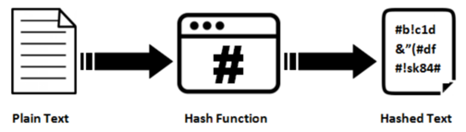

Figure - Hashing Process

The majority of cryptographic hash functions accept any length string as input and return a fixed-length hash value. Figure 2 depicts the general process of a hash function.

A cryptographic hash function must be cryptanalytically resistant to all known types of attacks. The security level of a cryptographic hash function has been determined using the following properties in theoretical cryptography:

* Pre-image resistance

Given a hash value h, it should be hard to determine any message m such that h = hash(m). This concept is connected to that of a one-way function. Functions that do not have this property are susceptible to preimage attacks.

* Second pre-image resistance

Given an input m1, it should be hard to determine a different input m2 such that hash(m1) = hash(m2). This property is occasionally stated to as weak collision resistance. Functions that do not have this attribute are susceptible to second-preimage attacks.

* Collision resistance

It should be hard to determine two different messages m1 and m2 such that hash(m1) = hash(m2). Such a pair is referred as cryptographic hash collision. This attribute is occasionally called as strong collision resistance. It needs a hash value at least twice as long as that required for pre-image resistance; or else collisions may be identified by a birthday attack.

**Blockchain**

At its most basic level, blockchain technology permits a network of computers to have a consensus on the true status of a distributed ledger at regular intervals. Blockchain network users submit potential transactions to participating nodes. The network then chooses a publishing node to update the pending transaction. Once this is done, transaction is propagated to non-publishing nodes. Transactions are logged chronologically – with information being passed from the first transaction (or blocks) up to the last. This repetitive process forms an immutable chain on which all blocks are interconnected with each other.

Transactions are inserted to the blockchain when a publishing node creates a block. A block may represent various types of data from simple texts to complicated ones such as digital rights or intellectual property. It is divided into two parts, header and body. Header contains metadata and body is for the actual data being persisted in the blockchain. Below is a typical specification of these 2 parts:

1. Block Header

* Previous block header’s hash value
* Hash representation of block data
* Timestamp
* Size of the block
* Nonce value. In Bitcoin and other Proof-of-Work blockchains, this is a number manipulated by the publishing node to solve the hash puzzle.

1. Block Data

* 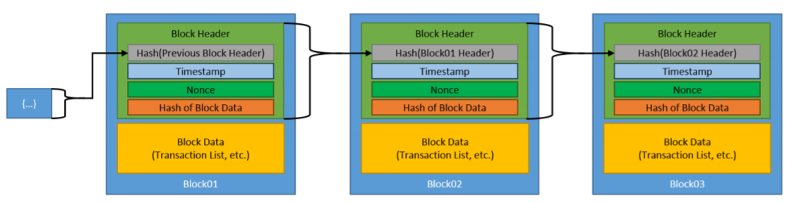Actual data (text, files)

Figure - Generic Blockchain Transactions

Figure 3 shows how blockchain works given a simple data of text. The initial block is referred to the genesis block and is automatically generated upon the chain’s creation. This genesis block is the seed and considered as reference of all blocks going forward. Blocks are linked through each block containing the hash value of the previous block’s header, thus creating the chain. In case a previously published block was changed, it generates a different hash. This creates a domino effect on all subsequent blocks to also have a different hash because they contain the hash of the altered block.

An essential part of the blockchain is identifying which user publishes the next block or become the next publishing node. This is solved by implementing a consensus model. The common model used is to compete on who publishes it and winning an incentive in doing so.

Once a user joins a blockchain network, they agree to the preliminary state of the system. This is documented in the only pre-configured block or the genesis block. Each blockchain network have a genesis block on to which all subsequent blocks are referenced to. Each block must be valid and can be validated independently by each blockchain network user.

**Proof of Authority (POA) - Clique**

In a Proof of Authority (PoA) consensus algorithm, a set of trusted nodes called Authorities, each recognized by their unique identifier, are responsible for mining and validating the blocks in the blockchain. Clique is a PoA protocol implemented in Geth. Figure 4 depicts the block creation process for this algorithm.

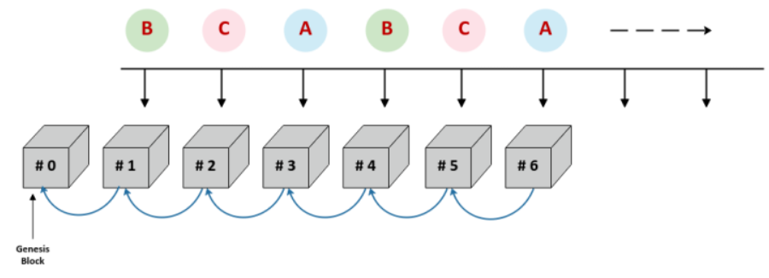

Figure - Clique PoA Block Creation Process

The Clique consensus protocol adheres to the following rules:

- Set of trusted authorities are referred to as the "Signers"

- Process of mining a block is referred to as "Sealing a block"

- WHEN the next block is identified by BLOCK_NUMBER and the number of signers is identified by SIGNER_COUNT

AND the signers are lexicographically sorted by their unique identifiers in a list

THEN the next block is sealed by the signer located at the index

BLOCK_NUMBER % SIGNER_COUNT, where % is the modulus operator

The signers compile and execute network transactions into a block, updating the world state. At the fixed interval referred to as the BLOCK_PERIOD, the next signer in the list (identified by BLOCK_NUMBER % SIGNER_COUNT) calculates the hash of the block and then signs the block using its private key (sealing the block). The sealed block is then broadcast to all nodes in the network.

**InterPlanetary File Storage (IPFS)**

IPFS is a distributed platform for storing and retrieving files, websites, applications and data. It has rules that regulate in what manner data and content move around on the network. These rules are similar to Kademlia, the peer-to-peer distributed hash table (DHT) popularized by its use in the BitTorrent protocol.

IPFS is essentially a peer-to-peer system for getting and sharing IPFS objects. An IPFS object is a data structure have two fields:

* Data: a blob of unstructured binary data of size < 256 kB.
* Links: an array of Link structures. These are links to other IPFS objects. Links have 3 sub-parts:
  + Name: the name of the Link.
  + Hash: the hash of the linked IPFS object.
  + Size: the cumulative size of the linked IPFS object, including following its links.

IPFS builds a Merkle DAG, a blend of a Merkle Tree and a Directed Acyclic Graph (DAG).

A Merkle tree summarizes all of the transactions in a block by generating a digital fingerprint of the complete collection of transactions, allowing a user to check whether or not a transaction is included in the block. Merkle trees are made by hashing pairs of nodes repeatedly until only one hash remains (this hash is called the Root Hash, or the Merkle Root). They are built from the ground up, utilizing individual transaction hashes (known as Transaction IDs). Each non-leaf node is a hash of its previous hashes, while each leaf node is a hash of transactional data. Merkle trees are binary, hence an even number of leaf nodes is required. The last hash is repeated once to establish an even number of leaf nodes if the number of transactions is odd.

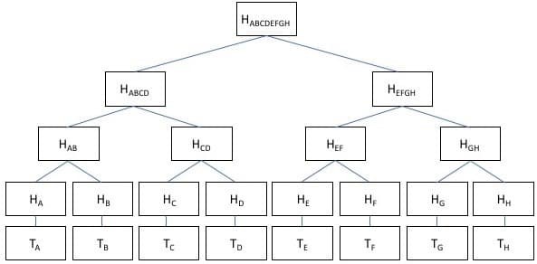

Figure - Merkle Tree Implementation using Hashes

A directed acyclic graph (DAG) is a visual representation of a sequence of events. A graph depicting the order of the activities is visually portrayed as a group of circles, each representing an activity, some of which are connected by lines, which represent the flow from one action to the next. Each circle is referred to as a "vertex," and each line is referred to as a "edge". "Directed" signifies that each edge has a specific direction, implying that each edge reflects a single directional flow from one vertex to the next. The term "acyclic" refers to a network that contains no loops (or "cycles"), meaning that if you follow an edge connecting one vertex to another, there is no way to return to the original vertex.

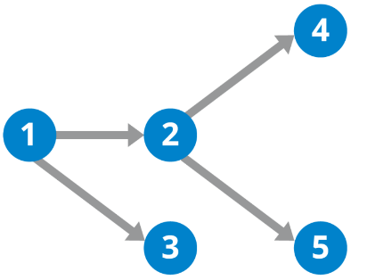

Figure - DAG Illustration

A Merkle DAG is a DAG in which each node has an identification that is generated by hashing the content of the node — any opaque payload carried by the node, as well as a list of its children's identifiers — by utilizing a cryptographic hash function like SHA256. This brings some important considerations:

Merkle DAGs can only be built from the leaves, or nodes that have no offspring. Parents come after children because the identifiers for the children must be computed ahead of time in order to link them. Every node in a Merkle DAG is the root of a (sub)Merkle DAG, and the parent DAG contains this subgraph.

Merkle DAG nodes cannot be changed. Any change to a node's identity affects all ascendants in the DAG, effectively resulting in the creation of a new DAG.

Merkle DAGs are like Merkle trees, but they don't have to be balanced, and each node can have a payload. Many branches can re-converge in DAGs, or, to put it another way, a node can have multiple parents.

Content addressing is the process of identifying a data object (such as a Merkle DAG node) based on the value of its hash. As a result, the node identifier is referred to as the Content Identifier, or CID.

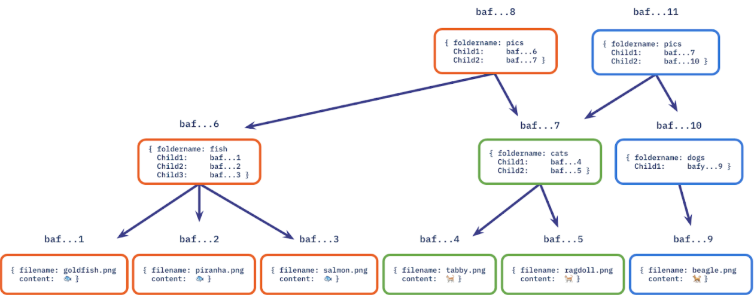

Figure - Merkle DAG Implemented on a File System

**Keccak**

The hash algorithm used in Clique is Keccak, since Clique is based off Ethereum.

Keccak is a family of hash functions that is based on the sponge construction, and hence is a sponge function family. In Keccak, the underlying function is a permutation chosen in a set of seven Keccak-f permutations, denoted Keccak-f[b], where b∈{25,50,100,200,400,800,1600} is the width of the permutation. The width of the permutation is also the width of the state in the sponge construction.

The state is organized as an array of 5×5 lanes, each of length w∈{1,2,4,8,16,32,64} and b=25w. When implemented on a 64-bit processor, a lane of Keccak-f[1600] can be represented as a 64-bit CPU word.

We obtain the Keccak[r,c] sponge function, with parameters capacity c and bitrate r, if we apply the sponge construction to Keccak-f[r+c] and by applying a specific padding to the message input.

Table 1 - Keccak Parameters Per Length

|  |  |  |  |  |  |  |
| --- | --- | --- | --- | --- | --- | --- |
|  | ***r*** | ***c*** | **Output length (bits)** | **Security level (bits)** | **Mbits** | **d** |
| **SHAKE128** | 1344 | 256 | unlimited | 128 | 1111 | 0x1F |
| **SHAKE256** | 1088 | 512 | unlimited | 256 | 1111 | 0x1F |
| **SHA3-224** | 1152 | 448 | 224 | 112 | 1 | 0x06 |
| **SHA3-256** | 1088 | 512 | 256 | 128 | 1 | 0x06 |
| **SHA3-384** | 832 | 768 | 384 | 192 | 1 | 0x06 |
| **SHA3-512** | 576 | 1024 | 512 | 256 | 1 | 0x06 |
| **cSHAKE128** | 1344 | 256 | unlimited | 128 | 0 | 0x04 |
| **cSHAKE256** | 1088 | 512 | unlimited | 256 | 0 | 0x04 |

Table 1 shows the parameters defining the standard instances. Parameters of the standard FIPS 202 and SP 800-185 instances. The values of Mbits and d assume that the input to these functions is made of bytes.

The value of the capacity c and of the suffix Mbits jointly provide domain separation between the different instances. Because their input to Keccak never collide, domain-seprated instances give unrelated outputs and act as independent functions.

**Present State of COVID-19 Vaccine Certificate Storage**

Documents and certificates given out by various units (private and public) for COVID-19 are still on paper-form. There are some units that store the results in their server and can be accessed online thru their website. Same is true with giving out vaccine certificates.

Primary providers of vaccines are Local Government Units (LGUs) and they vary in implementation. Some only give out physical copies (certificates, cards) and others have virtual copies on their websites stored on their servers. There is a disconnect on a unified tracking of all these documents and might result to issues when these documents are used on different areas of the Philippines. The usual proposition to solve this is to create a unified website hosted in a central server.

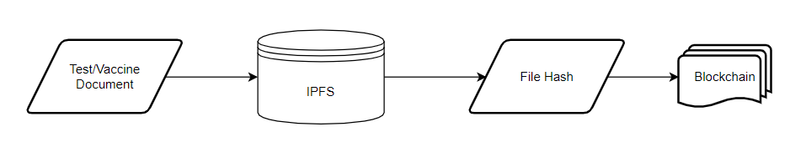**Proposed Documents Storage Structure**

Figure - Diagram of Proposed Solution

Figure 8 illustrates the summarized approach in solving the problem in document storage. The main components of this application are IPFS for file storage and blockchain for logging records of transaction in the system.

**Conceptual Framework**

Figure 9 - Conceptual Framework

Figure 9 depicts the conceptual framework. The users of the proposed application are patients, medical workers or other third-party requiring the patient to present a COVID-19 Vaccine Certificate. The users access the same application but with different levels of access depending on their role.

The inputs are the medical documents and distribution key. There are different types of keys which are discussed on Chapter 4. These keys are used to authenticate and unlock or lock the files.

Once all required inputs are provided, the file goes thru the necessary steps to access it. Depending on the type of transaction (insert a new file or retrieval), the keys provided should have enough privilege for it to succeed. The file hash is stored in the blockchain after going thru smart contracts. Once the blockchain successfully updated the network, provided file becomes an immutable component of both IPFS and blockchain network.

The researcher conducted interviews and probing to gather necessary information in building the proposed application. Also, differentiating each users on their level of access and scope of functionality are included on the specifications.

**Chapter Four**

# **METHODOLOGY**

Figure - Prototype Model Phases and Process

Figure 10 illustrates Prototype Model used by the researcher in developing the proposed study which is under the family of System Development Life Cycle (SDLC). Prototyping was used to ensure faster turnaround time on each phase while addressing client’s requirements and feedbacks. This model also enables the researcher and client to have discussions in between development cycles.

## **4.1 Requirements Modeling**

The Prototype Model starts with outlining the requirements. The researcher conducted an initial investigation to determine the purpose and utilization of the application coupled with the nature and scope of the study. It is also in this stage that the researcher requested permission from medical unit authorities and other parties to conduct the study and all relevant data and information were examined.

Fact-finding was used via interviews and probing of processes to build a logical model of the application. With this investigation, the researcher was able to piece out a picture of transactions involved and analyzed them against the proposed solution. This information also enabled the researcher to identify critical decisions geared toward implementing the application.

For vaccination records, citizens are encouraged to register online via the web portal. This ensures a scheduled slot on a specified date. On the day of vaccination, patient is checked up by a physician to ensure he is fit for vaccination. The physician’s findings are logged on the system. Upon issuing a go signal, patient can now be vaccinated. After vaccination, authorized medical unit signs a vaccination card while tagging the patient in their system as fully vaccinated.

Mocked test data were used for the application prototype. This is due to various privacy regulation such as Health Insurance Portability and Accountability Act (HIPAA). This is a United States created health law adopted by medical facilities in the Philippines.

Below are requirements grouped by specific role:

Patient

* Register and Login – register to gain access to the system
  + Upon registration, system creates private and public keys to be used for data encryption
* Download Vaccine Certificate
* View QR Code for Vaccine Record Summary
* View Record Summary Details

Verifying Third Party

* Publicly Available
* Validate Vaccine Certificate if existing in system

Physician/Medical Unit

* Register and Login – register to gain access to the system
* Create vaccine record for patient

## **4.2 Quick Design**

After identifying the requirements, a design of the proposed application is created. This is not a detailed design with complete technical specifications but a simplified one with critical aspects of the solution. This phase gives a bird’s eye view to the client of the application.

**4.2.1 Functional Specifications**

**Application Users**

Patients

- Provides data which in turn converted to information needed to generate vaccine certificates.

Medical Unit

- Creates vaccine record for recognized patients by the system.

Verifying 3rd Party

- Has the capability to verify patient's info via uploading vaccine certificates or scanning vaccine QR code.

**Application Responsibilities**

The primary responsibilities of the application are:

- provide patient easy access to their vaccine information

- allow external parties (private companies, mall establishments) to verify vaccine records

- automatic vaccine certificate generation once necessary information is available

- ease of use for medical personnel in the upkeep of vaccine records

- provide other means of uniqueness such as QR code to verify authenticity

- maintain data integrity by storing information in a blockchain setup

**General Requirements**

- The application shall allow patients to download vaccine certificates and view their vaccine record

- The application shall provide QR codes for patient information and vaccine information

- The application shall store transactions in a blockchain network

- The application shall store encrypted files in IPFS

- The application shall allow 3rd parties to verify vaccine information authenticity either via uploading a file or scanning a QR code

- The application shall provide a facility for medical unit to input vaccination transaction and records

- The application shall generate QR code and vaccine certificates once patient vaccine information is available

**4.2.1.1 Context Diagram**

Figure - Context Diagram

The context diagram shown in Figure 11 summarizes the application on inputs and outputs of the system and targeted users. On general, users of the application are required to provide public/private keys and vaccine details. Application generates vaccine certificate and summary details based off these details. After file generation, it triggers and executes various processes to upload, encrypt/decrypt, or release files. Note that this is a general illustration of inputs and outputs.

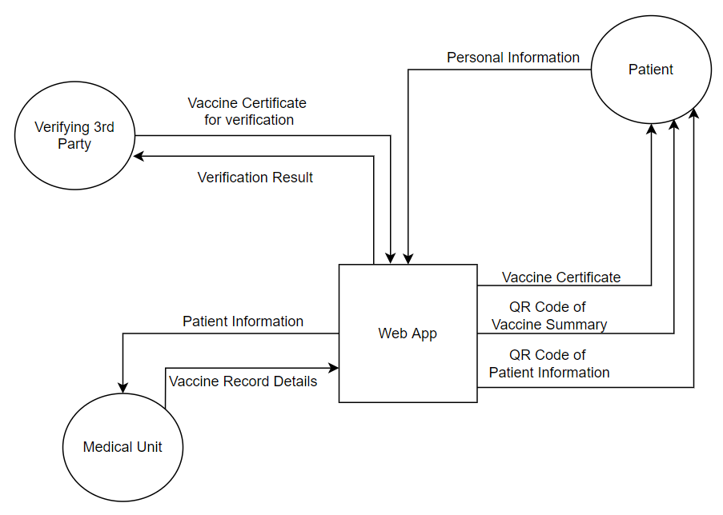**4.2.1.2 Data Flow Diagram**

Figure - Data Flow Diagram

Figure 12 illustrates how various types of users receives and provides information to the application and how the application provides and receives data from users. This also mentions the executing process to generate the data.

It is important to note that Patients are the crucial part of data flow since most of the essential information comes from them. Both Medical Unit and Verifying 3rd Party have auxiliary processes that consumes Patient data.

The web application serves as the gateway for all types of users to access vital functionalities such as record creation and validation. Within the application, the researcher will implement role access for it to recognize the user and delegate the appropriate task or functionality assigned to its type. In this way, data will be protected and ensured of its access.

It is important for the application to implement security measures for the Patient type user as it will involve disclosure of personal information.

**4.2.1.3 Use Case Diagram**

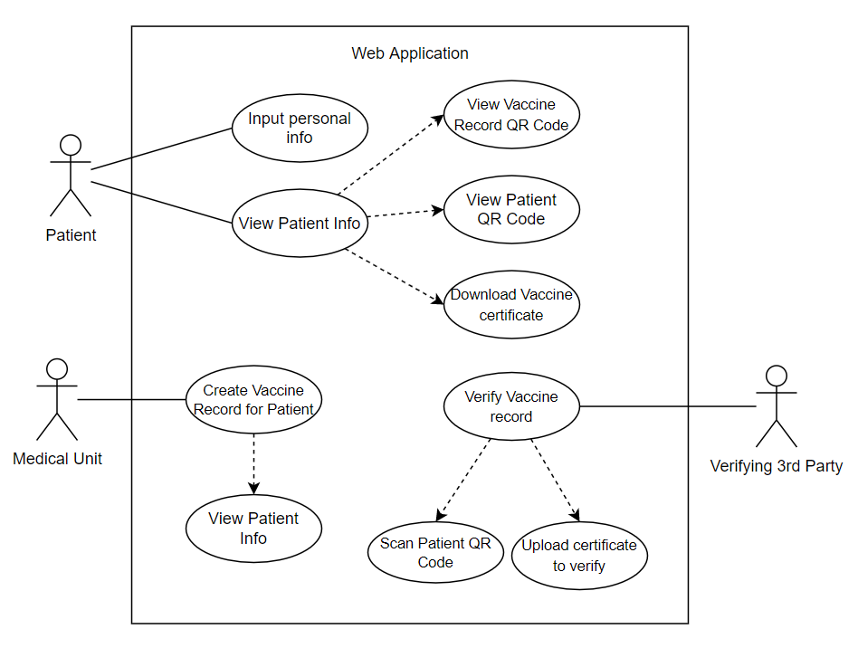

Figure - Use Case Diagram

The suggested application's development is not solely dependent on the system's functionality. It also depends on the workflow procedure that needs to be identified, implemented, and followed. The components of the proposed application are demonstrated in Figure 13 and utilized a Use Case Diagram. The patient, being the central user of this system provides appropriate keys with reference to the executing process. These in turn can trigger uploading or granting of view access to either medical unit or a third party. For the 3rd party validators, it is expected that they have codes and files generated from the web application for it to have a successful transaction. In the event the item they want to be validated is not from the system, it will result in an error notification.

**4.2.1.4 Functional System Flowcharts of the Proposed Application**

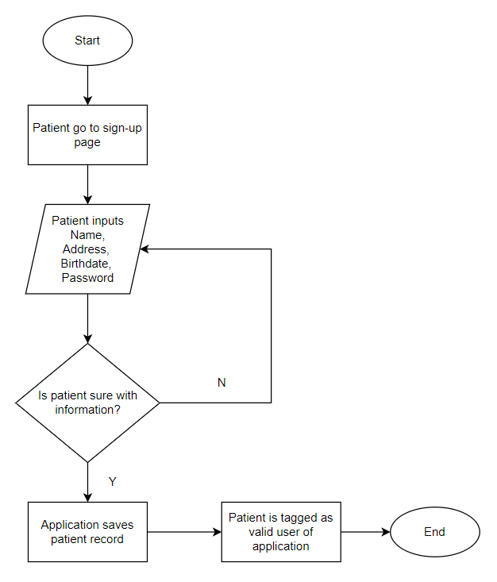

Figure - Patient Registration Flowchart

Figure 14 is about Patient Registration. Once the patient has navigated to the sign-up page, he is required to input personal information. Once he has finalized the information, the application saves the record and triggers the process for the user to be tagged as a valid user of the application.

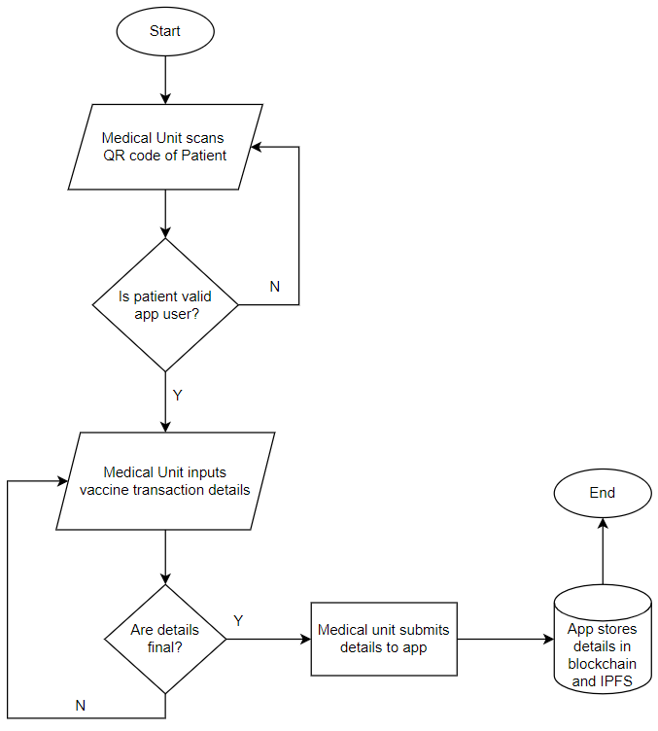

Figure - Vaccine Record Creation Flowchart

Figure 15 illustrates vaccine record creation. Upon scanning a valid patient QR Code, Medical Unit is required to input vaccine details such as vaccine brand, lot number and vaccination date. Once information is finalized, it is submitted to the application and stored in IPFS and blockchain. If the scanned patient QR code is invalid, Medical Units are not allowed to enter vaccine information.

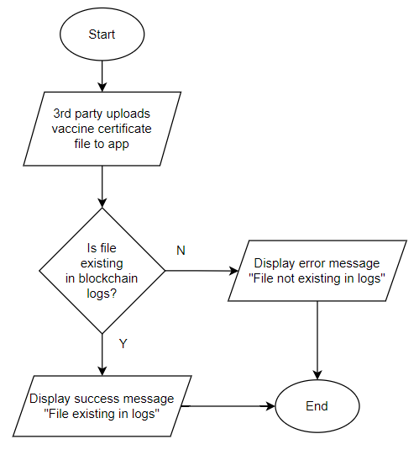

Figure - Verify Vaccine Certificate File

Figure 16 tackles vaccine certificate file verification. 3rd party validators upload the vaccine certificate file into the application. It generates a file hash for the uploaded file then tries to find said hash from the blockchain logs. If the hash exists, the file is deemed as valid and a success message is displayed. But if the hash does not exist, it displays an error message.

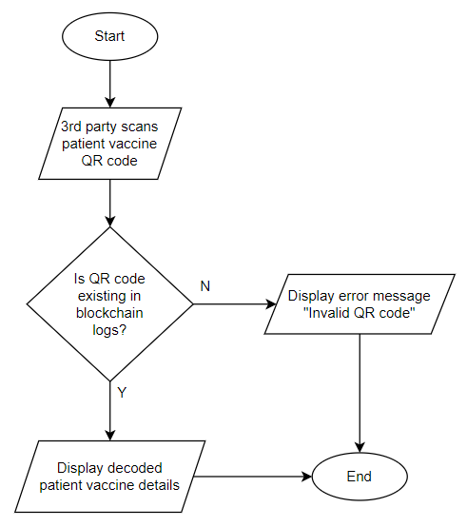

Figure - Verify Vaccine QR Code

Figure 17 is about vaccine QR code verification. 3rd party validators scan a vaccine QR code from a Patient. Application extracts summary hash from the QR code. If the hash exists, the QR code is deemed as valid and a success message is displayed. But if the hash does not exist, it displays an error message.

**4.2.2 Technical Specifications**

**4.2.2.1 General Software Requirements**

**Frontend Specifications**

Table 2 - Frontend Specifications

|  |  |
| --- | --- |
| Framework | Responsive Web Application |
| Language | ReactJS, Javascript |
| Other plugins (downloaded via Node Package Manager (NPM)) | axios  bootstrap  js-file-download |

**Backend Specifications**

Table 3 - Backend Specifications

|  |  |
| --- | --- |
| Framework | Web API |
| Language | NodeJS |
| Database | MSSQL Server 2019 |
| Other Plugins (downloaded via Node Package Manager (NPM)) | sequelize  html-pdf  ipfs-http-client  openpgp  qrcode |

**Blockchain**

Table 4 - Blockchain Specifications

|  |  |
| --- | --- |
| Language | Solidity |
| Blockchain Protocol | Ethereum - Go Eth (GETH) |
| Consensus Protocol | GETH Clique PoA |
| Client-Wallet Interface | Web3 |
| CryptoCurrency Wallet | MetaMask |

**4.2.2.2 High-Level System Design Diagram**

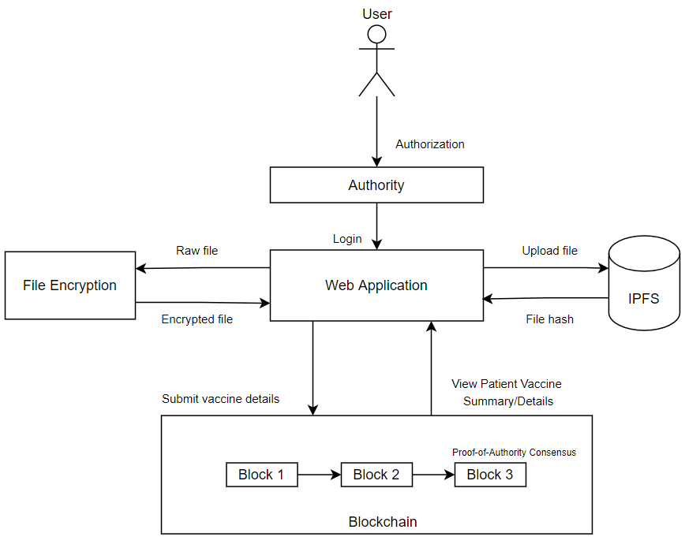

Figure - High-Level System Design Diagram

The diagram shows four core components of the application. The web application is the user’s gateway for interaction and access its various functionalities. From the web app, file encryption is then called for data masking feature. It is worth noting that data masking is a prerequisite process for a file to be uploaded in IPFS. Any file transaction done within IPFS are logged to the blockchain. Other transaction logged within the blockchain is summary details of a vaccine event. In this diagram, the web application is highlighted as the mediator between IPFS, File Encryption and blockchain. Main function of the web app is to orchestrate the http requests and responses for these components.

**4.2.2.3 System Architecture Diagram**

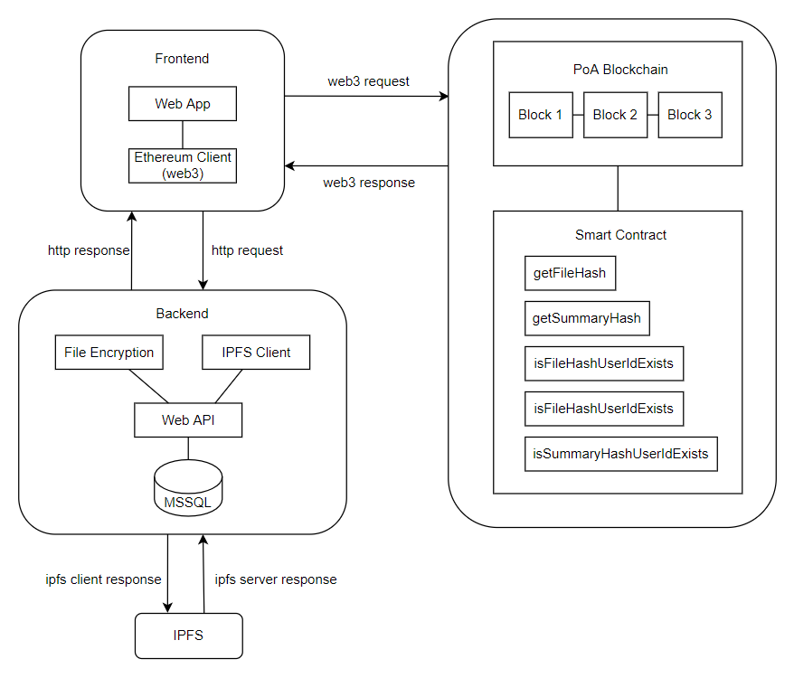

Figure - System Architecture Diagram

The frontend sector is composed of the web application and Ethereum Client. As discussed with the High-Level System Design, this is the gateway for the user to trigger events for transactions. In this application, web3 was used which is a frontend Ethereum client and is pluggable with ReactJS. This is the reason why blockchain interactions are triggered from the web application.

The backend sector is composed of the Web API, File Encryption, Database and IPFS Client. From here, the frontend makes http requests to process file encryption/decryption and IPFS uploads and downloads. The IPFS client used was only pluggable with NodeJS which is why all IPFS interactions are only done in the backend. CRUD (create, read, update, delete) transactions in the database are also initiated in the backend.

The blockchain sector is composed of the blockchain itself and smart contracts. As specified above, it is only the frontend that can trigger requests to smart contracts. It is worth noting that for file transactions, it is first processed from the backend to generate a file hash which is then passed to the frontend and finally, the frontend making a request to the blockchain to process file hash. As per the functional specifications from previous area of this chapter, it is in this sector that the final processing of transaction logs from the vaccine record creation happens. Once a log is made from the blockchain, the application deems the vaccine details final and valid

**4.2.2.5 Data Structure Diagrams**

**4.2.2.5.1 Blockchain Data and Function Mapping**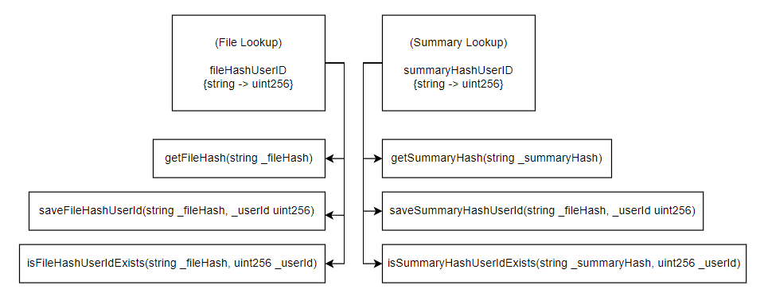

Figure - Blockchain Data and Function Mapping

The blockchain is validated by two lookups: file and summary. Both lookups are of keyvalue pair with typings of {string (key), uint256 (value)}. This maps out patients with one summary or file hash.

Both lookups have separate functions for CRUD as this follows with the Solidity Coding Standard of separation of concerns and updating of values inside the blockchain.

**4.2.2.5.2 Relational Database Diagram**

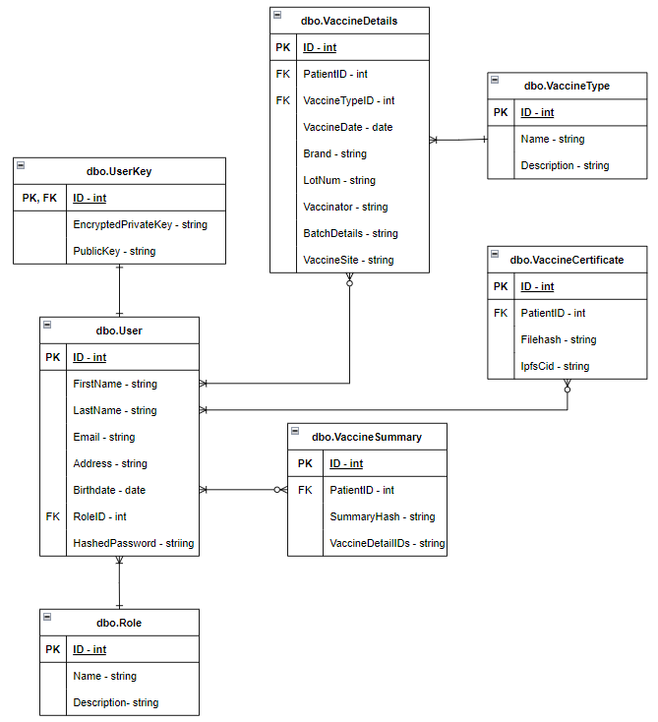

Figure - Relational Database Diagram

It is important to note the segregation of VaccineSummary and VaccineCertificate. This allows for better handling of information when being transmitted and retrieved from the blockchain. Also, a crucial entity of the schema is the User table as this is being referenced by other tables via its primary key.

**4.2.2.6 Transactional Operation Diagram**

Figure - Transactional Operation Diagram

Figure 22 illustrates the operations that exist in the proposed application. It is divided according to the users triggering the process. The crucial process of generating the private and public keys is prompted by the patient. Without these keys, medical personnel cannot upload files which in turn, the third parties are not able to request any file validation.

The diagram attempts to highlight the overlaps of processes between the application’s entities. It is worth noting that blockchain and IPFS both interlaps with vaccine record creation and validation processes. This is because both entities are crucial to maintain the immutable nature of the data.

Also, medical units are responsible in most of the record modification as both patient and 3rd party validators are just concerned with data acquisition.

**4.2.2.7 Technical Flowcharts**

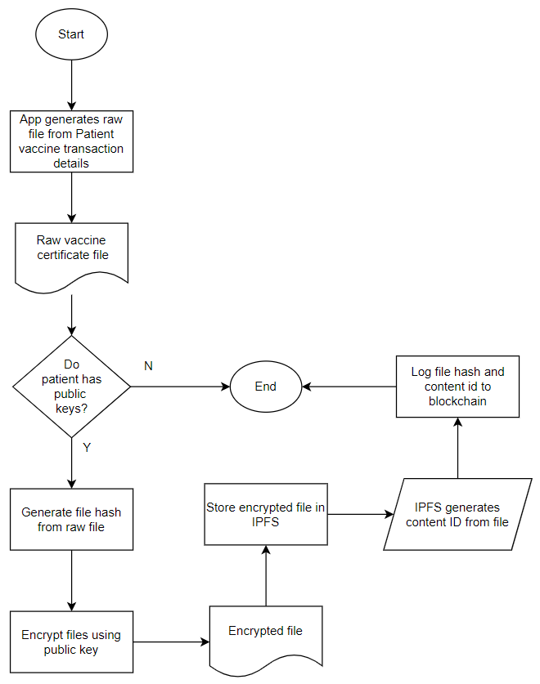

Figure - File Storage in Blockchain and IPFS Flowchart

Figure 23 dwells with file storage in blockchain and IPFS. Given vaccine record is created, the application generates a raw .PDF file from the details. It then retrieves patient's public key. If patient has no public key, process is aborted. If public key is existing, application proceeds to generate a file hash then encrypt the file using the public key. Encrypted file is then stored in IPFS. IPFs generates a Content Identifier (CID) from this transaction. File hash and CID are be logged onto the blockchain.

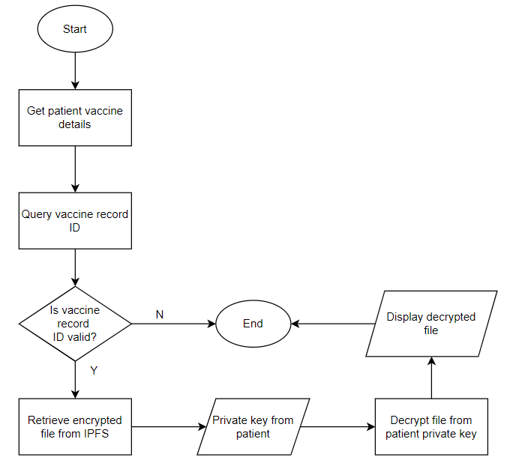

Figure - File Retrieval Flowchart

Figure 24 tackles file retrieval. Application first retrieves patient details and identify patient's unique identifier. If vaccine record exists for the patient, application proceeds to query patient's file hash from the blockchain. If hash exists, it proceeds to retrieve the encrypted file from IPFS. After this, patient's private key is used to decrypt the vaccine certificate file. Decrypted file is now available for download and displayed in the application.

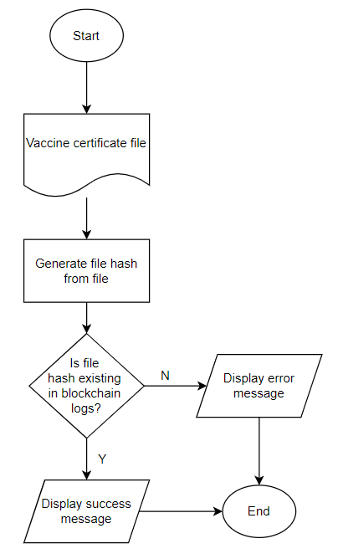

Figure - Validate File from Blockchain Flowchart

Figure 25 discusses file validation from the blockchain. 3rd party uploads a raw file to the application. Application generates a file hash from the raw file. It then queries the file hash if it exists in the blockchain logs. If exists, it displays a successful verification message. And if not, it displays an error message.

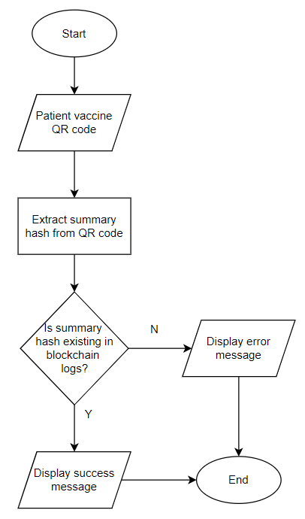

Figure - Validate QR Code from Blockchain Flowchart

Figure 26 illustrates QR code validation from the blockchain. 3rd party scans a patient vaccine QR code. Application extracts summary hash from QR Code. If summary hash exists, it displays a successful verification message. And if not, it displays an error message.

**Chapter Five**

# **RESULTS AND DISCUSSION**

## **5.1 Functionalities of the System**

This section tackles the various functionalities included in the application and shows screenshots of the development.

Table 5 - Functionality of the System

|  |  |  |
| --- | --- | --- |
| **Functionality** | **Intended User/s** | **Description** |
| Patient Registration | Patient | Allows unregistered users make an account |
| Patient Login | Patient | Entry point for patients using email and password |
| Patient Home Screen | Patient | Displays overview of patient details |
| Vaccine Record Creation | Medical Unit | Allows authorized medical personnel to input vaccination details to the system |
| Vaccine Certificate Validation | Third Party Validators | Allows validators to upload and verify a vaccine certificate file |
| Scan Summary QR Code | Third Party Validators | Allows validators to verify patient details via QR code |

Table 5 shows the various functionalities built into the system. It maps out to the intended users and description. It is important to note that most of the functionality is patient-centric and user experience was made robust to their needs. Medical units have the crucial role of creating vaccine records while patient and 3rd party validators are particularly concerned in viewing and gaining access to the information.

**Patient Registration**

Figure - Patient Registration Screen

This is the catalyst for a patient to be signed-up in the system. It triggers generation of public and private keys in the backend which is crucial for encryption and uploading to IPFS.

**Patient Login**

Figure - Patient Login Screen

The patient is required to input email (as username) and password to be able to access related vaccine records and details.

**Patient Home Screen**

Figure - Patient Home Screen (Upper Section)

Upper part of the home screen is the patient’s profile data: Full name, profile photo, address and patient code. Patient QR code is displayed. This code is used later if patient decides to get vaccinated. It signifies that the patient is currently registered to the system.

Figure - Patient Home Screen (Lower Section)

Lower part of the home screen is for vaccination details. If the patient already got vaccinated, this section is displayed. It shows a summary of vaccine doses and a QR code for these details. This code can be used for validation of third party such as establishments to validated if patient was indeed vaccinated. The ‘Download Certificate’ button downloads the vaccine certificate file

**Vaccine Record Creation**

Figure - Vaccine Record Creation Screen

For medical personnel doing the vaccination, this page is available for them. A valid Patient QR code is required before the system allows encoding of vaccination dose detail. Once details are confirmed, a MetaMask (blockchain plugin) pops up to confirm the transaction. This logs the transaction to the blockchain

**Vaccine Certificate Validation**

Figure - File Validation (Successful)

Figure - File Validation (Failure)

Figure 32 and 33 depicts file validation. For third-party validators that wants to authenticate a Vaccine Certificate file, this page is available. It requires the user to upload the file and displays a prompt that tells if file is valid or not (within the blockchain logs context)

**Scan Summary QR Code**

Figure - Scan Summary QR Code Screen

In figure 34, it illustrates validation via summary QR code. For third-party validators that wants quick details of patient’s vaccine records, it requires a summary QR code from a patient and displays related details. QR code is invalid if app founds out it’s not existing within the blockchain logs.

## **5.2 Implementation of Proof of Authority and Keccak Hash**

The main purpose of using blockchain is to log and validate user transactions. Transactions we want to monitor and be authenticated are summary details and vaccine certificate creation. Apart from file and summary hashes, the app includes supporting details such as userId and Content Identifier from IPFS.

Assuming the application have obtained hashes and Content Identifiers, it proceeds to create a blockchain of transactions given the files were already uploaded to IPFS and CIDs are generated. JSON Objects are used as format of the payload. Summary details of vaccine records are also stored in the blockchain

Both file and summary hash lookup have the same structure:

<hash>: <userId>

Generated CID Sample:

[QmZkJLp7PJGMc3mMSxTeLtyQCRqZ5CudGdjPB3jjTSFaoX](https://cid.ipfs.io/#QmZkJLp7PJGMc3mMSxTeLtyQCRqZ5CudGdjPB3jjTSFaoX): 1001

Above sample is comprised of CID which has the encoded identifier of the file uploaded in IPFS. This identifier makes the file unique and used as look up when retrieving files from the file storage network.

**Clique Proof-of-Authority**

The application used Clique Proof of Authority consensus. Below is a simulation of various test cases:

*// block represents a single block signed by a parcitular account, where*

*// the account may or may not have cast a Clique vote.*

**type** block **struct** {

signer **string** *// Account that signed this particular block*

voted **string** *// Optional value if the signer voted on adding/removing someone*

auth **bool** *// Whether the vote was to authorize (or deauthorize)*

checkpoint []**string** *// List of authorized signers if this is an epoch block*

}

*// Define the various voting scenarios to test*

tests **:=** []**struct** {

epoch **uint64** *// Number of blocks in an epoch (unset = 30000)*

signers []**string** *// Initial list of authorized signers in the genesis*

blocks []block *// Chain of signed blocks, potentially influencing auths*

results []**string** *// Final list of authorized signers after all blocks*

failure **error** *// Failure if some block is invalid according to the rules*

}{

{

*// Single signer, no votes cast*

signers**:** []**string**{"A"},

blocks**:** []block{

{signer**:** "A"}

},

results**:** []**string**{"A"},

}, {

*// Single signer, voting to add two others (only accept first, second needs 2 votes)*

signers**:** []**string**{"A"},

blocks**:** []block{

{signer**:** "A", voted**:** "B", auth**:** true},

{signer**:** "B"},

{signer**:** "A", voted**:** "C", auth**:** true},

},

results**:** []**string**{"A", "B"},

}, {

*// Two signers, voting to add three others (only accept first two, third needs 3 votes already)*

signers**:** []**string**{"A", "B"},

blocks**:** []block{

{signer**:** "A", voted**:** "C", auth**:** true},

{signer**:** "B", voted**:** "C", auth**:** true},

{signer**:** "A", voted**:** "D", auth**:** true},

{signer**:** "B", voted**:** "D", auth**:** true},

{signer**:** "C"},

{signer**:** "A", voted**:** "E", auth**:** true},

{signer**:** "B", voted**:** "E", auth**:** true},

},

results**:** []**string**{"A", "B", "C", "D"},

}, {

*// Single signer, dropping itself (weird, but one less cornercase by explicitly allowing this)*

signers**:** []**string**{"A"},

blocks**:** []block{

{signer**:** "A", voted**:** "A", auth**:** false},

},

results**:** []**string**{},

}, {

*// Two signers, actually needing mutual consent to drop either of them (not fulfilled)*

signers**:** []**string**{"A", "B"},

blocks**:** []block{

{signer**:** "A", voted**:** "B", auth**:** false},

},

results**:** []**string**{"A", "B"},

}, {

*// Two signers, actually needing mutual consent to drop either of them (fulfilled)*

signers**:** []**string**{"A", "B"},

blocks**:** []block{

{signer**:** "A", voted**:** "B", auth**:** false},

{signer**:** "B", voted**:** "B", auth**:** false},

},

results**:** []**string**{"A"},

}, {

*// Three signers, two of them deciding to drop the third*

signers**:** []**string**{"A", "B", "C"},

blocks**:** []block{

{signer**:** "A", voted**:** "C", auth**:** false},

{signer**:** "B", voted**:** "C", auth**:** false},

},

results**:** []**string**{"A", "B"},

}, {

*// Four signers, consensus of two not being enough to drop anyone*

signers**:** []**string**{"A", "B", "C", "D"},

blocks**:** []block{

{signer**:** "A", voted**:** "C", auth**:** false},

{signer**:** "B", voted**:** "C", auth**:** false},

},

results**:** []**string**{"A", "B", "C", "D"},

}, {

*// Four signers, consensus of three already being enough to drop someone*

signers**:** []**string**{"A", "B", "C", "D"},

blocks**:** []block{

{signer**:** "A", voted**:** "D", auth**:** false},

{signer**:** "B", voted**:** "D", auth**:** false},

{signer**:** "C", voted**:** "D", auth**:** false},

},

results**:** []**string**{"A", "B", "C"},

}, {

*// Authorizations are counted once per signer per target*

signers**:** []**string**{"A", "B"},

blocks**:** []block{

{signer**:** "A", voted**:** "C", auth**:** true},

{signer**:** "B"},

{signer**:** "A", voted**:** "C", auth**:** true},

{signer**:** "B"},

{signer**:** "A", voted**:** "C", auth**:** true},

},

results**:** []**string**{"A", "B"},

}, {

*// Authorizing multiple accounts concurrently is permitted*

signers**:** []**string**{"A", "B"},

blocks**:** []block{

{signer**:** "A", voted**:** "C", auth**:** true},

{signer**:** "B"},

{signer**:** "A", voted**:** "D", auth**:** true},

{signer**:** "B"},

{signer**:** "A"},

{signer**:** "B", voted**:** "D", auth**:** true},

{signer**:** "A"},

{signer**:** "B", voted**:** "C", auth**:** true},

},

results**:** []**string**{"A", "B", "C", "D"},

}

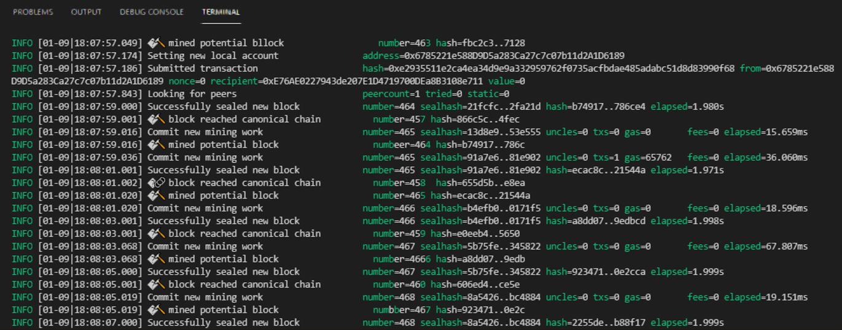When someone uploads a certificate to the system, the application sends the transaction log to the blockchain.

Figure - Node Blockchain Logs for File Upload



Figure - Detected Metamask Address of Log Sender

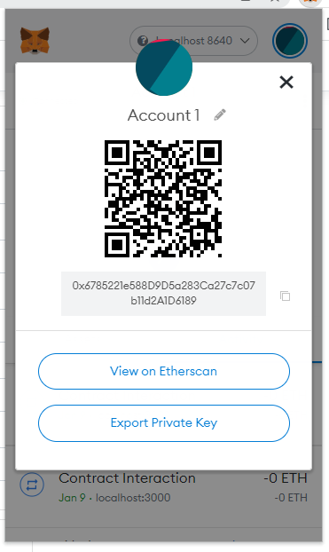

Figure - Metamask account details of vaccine file uploader

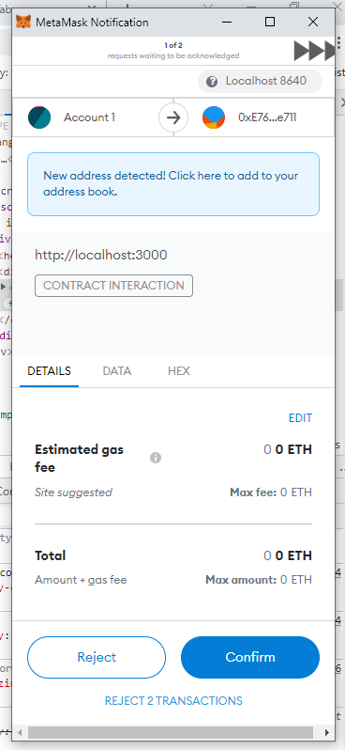

Figure - Metamask Notification of File Upload Transaction

**Keccak-256**

The hashing algorithm used by Ethereum (implemented in Clique POA) is Keccak-256. Below is a simulation of the algorithm using a simple input string:

Keccak256 presets:

bitrate_bits = 1088

capacity_bits = 512

output_bits = 256

bitrate_bytes = 136 -- convert bitrate_bits to bytes

multirate_padding(used_bytes, align_bytes)

padlength = align_bytes - used_bytes

zero_elements = [0] * padlength - 2

padding = [1] + zero_elements + [128]

return padding

#example

#if used_bytes = 130, align_bytes = 136

#padlength = 136 - 130 = 6

#zero_elements = [0, 0, 0, 0]

#padding = [1, 0, 0, 0, 0 128]

bytesToLane(input_bytes)

accumulator = 0

for b in reversed(input_bytes)

accumulator = ( accumulator << 8 ) | b

#apply 8 bitwise left shit to accumulator then XOR with b

return accumulator

#example

#input_bytes = [104, 101, 108, 108, 111, 32, 119, 111]

each iteration results to (consecutively)

0

28416

7304960

1870077952

478739984128

122557435964416

31374703606918144

8031924123371070720

8031924123371070824

#final value is 8031924123371070824

-----------------------------------------------------------

input_text = "hello world"

1. Get byte array (input_byte_array) equivalent of input_text

input_byte_array = [104, 101, 108, 108, 111, 32, 119, 111, 114, 108, 100]

2. Pad input_byte_array using multirate_padding

used_bytes = input_byte_array.length = 11 (count number of elements inside array)

align_bytes = presets.bitrate_bytes = 136

padded_bytes = [104, 101, 108, 108, 111, 32, 119, 111, 114, 108, 100, 1, 0, 0, 0, 0, 0, 0, 0, 0, 0, 0, 0, 0, 0, 0, 0, 0, 0, 0, 0, 0, 0, 0, 0, 0, 0, 0, 0, 0, 0, 0, 0, 0, 0, 0, 0, 0, 0, 0, 0, 0, 0, 0, 0, 0, 0, 0, 0, 0, 0, 0, 0, 0, 0, 0, 0, 0, 0, 0, 0, 0, 0, 0, 0, 0, 0, 0, 0, 0, 0, 0, 0, 0, 0, 0, 0, 0, 0, 0, 0, 0, 0, 0, 0, 0, 0, 0, 0, 0, 0, 0, 0, 0, 0, 0, 0, 0, 0, 0, 0, 0, 0, 0, 0, 0, 0, 0, 0, 0, 0, 0, 0, 0, 0, 0, 0, 0, 0, 0, 0, 0, 0, 0, 0, 128]

3. Append another batch of zero elements to padded_bytes

zero_count = convertToBytes ( (presets.bitrate_bits + presets.capacity_bits) - presets.bitrate_bits )

= convertToBytes((1088 + 512) - 1088)

= 64

zero_elements = [0] * 64

padded_bytes += zero_elements

= [104, 101, 108, 108, 111, 32, 119, 111, 114, 108, 100, 1, 0, 0, 0, 0, 0, 0, 0, 0, 0, 0, 0, 0, 0, 0, 0, 0, 0, 0, 0, 0, 0, 0, 0, 0, 0, 0, 0, 0, 0, 0, 0, 0, 0, 0, 0, 0, 0, 0, 0, 0, 0, 0, 0, 0, 0, 0, 0, 0, 0, 0, 0, 0, 0, 0, 0, 0, 0, 0, 0, 0, 0, 0, 0, 0, 0, 0, 0, 0, 0, 0, 0, 0, 0, 0, 0, 0, 0, 0, 0, 0, 0, 0, 0, 0, 0, 0, 0, 0, 0, 0, 0, 0, 0, 0, 0, 0, 0, 0, 0, 0, 0, 0, 0, 0, 0, 0, 0, 0, 0, 0, 0, 0, 0, 0, 0, 0, 0, 0, 0, 0, 0, 0, 0, 128, 0, 0, 0, 0, 0, 0, 0, 0, 0, 0, 0, 0, 0, 0, 0, 0, 0, 0, 0, 0, 0, 0, 0, 0, 0, 0, 0, 0, 0, 0, 0, 0, 0, 0, 0, 0, 0, 0, 0, 0, 0, 0, 0, 0, 0, 0, 0, 0, 0, 0, 0, 0, 0, 0, 0, 0, 0, 0, 0, 0, 0, 0, 0, 0]

4. Convert padded_bytes to array of lanes (lane_array) and put then in a 5x5 2D array.

- get a batch of 8 elements from padded_bytes

- convertedBatch1ToLane = bytesToLane(batch)

- result is:

[[8031924123371070824L, 0, 0, 0, 0], [23358578, 0, 0, 9223372036854775808L, 0], [0, 0, 0, 0, 0], [0, 0, 0, 0, 0], [0, 0, 0, 0, 0]]

5. Process lane_array to permutation_rounds (greek alphabet methods - theta, rho and phi, chi, iota)

lanew

= (presets.bitrate_bits + presets.capacity_bits) // 25 #the floor division // rounds the result down to the nearest whole number

= 64

l

= int(log(lanew, 2))

= 6

number_of_rounds = 12 + 2 * l

= 24

## **5.3 Implementation of Merkle DAG**

The algorithm used in IPFS to manage content and assets is Merkle DAG. For the below example, a small size text file is used to better illustrate the process. The default chunk size of IPFS is 256Kb but in this example it is reduced to 32Kb to have appropriate representation using small sample files.

File 1

Name: cert_allen_smith.txt

Size: 86 bytes

Content:

File 2

Name: cert_john_doe.txt.txt

Size: 83 bytes

Content:

Generated Details for cert_allen_smith.txt:

Table 6 - Generated Hash Value for Sample Record #1

|  |  |  |
| --- | --- | --- |
| Node Type | Size (Bytes) | Hash |
| Root | 0 | [QmZkJLp7PJGMc3mMSxTeLtyQCRqZ5CudGdjPB3jjTSFaoX](https://cid.ipfs.io/#QmZkJLp7PJGMc3mMSxTeLtyQCRqZ5CudGdjPB3jjTSFaoX) |
| Links | 32 | [QmdsyzBk5nWmC7a92gaAuRHxWTQu6e4wwyv2bVmZtF7mcq](https://cid.ipfs.io/#QmdsyzBk5nWmC7a92gaAuRHxWTQu6e4wwyv2bVmZtF7mcq) |
| Links | 32 | [QmPsFk9hcP4WmN96r8mXYjV5rKCNNb94c95jfqLBNZvigT](https://cid.ipfs.io/#QmPsFk9hcP4WmN96r8mXYjV5rKCNNb94c95jfqLBNZvigT) |
| Links | 22 | [QmVVrfBPAnF5DC1DXDZH2yftW6MEoCSKXEQEbY5LKfFzAt](https://cid.ipfs.io/#QmVVrfBPAnF5DC1DXDZH2yftW6MEoCSKXEQEbY5LKfFzAt) |

Generated Details for cert_john_doe.txt:

Table 7 - Generated Hash Value for Sample Record #2

|  |  |  |
| --- | --- | --- |
| Node Type | Size (Bytes) | Hash |
| Root | 0 | [QmanmTVLostTHeeLiz8vr99QDWmVbmbd53rSA2iFoDcmXu](https://cid.ipfs.io/#QmanmTVLostTHeeLiz8vr99QDWmVbmbd53rSA2iFoDcmXu) |
| Links | 32 | [QmdsyzBk5nWmC7a92gaAuRHxWTQu6e4wwyv2bVmZtF7mcq](https://cid.ipfs.io/#QmdsyzBk5nWmC7a92gaAuRHxWTQu6e4wwyv2bVmZtF7mcq) |
| Links | 32 | [QmTfDsTDe3nVu7b3hij43R3mBzyhJZgVm9eFBewVb5FfKV](https://cid.ipfs.io/#QmTfDsTDe3nVu7b3hij43R3mBzyhJZgVm9eFBewVb5FfKV) |
| Links | 32 | [QmRF3DNTkA43a7AG26uva4n7pgR22ctz6PjZW4KMuN5Cvu](https://cid.ipfs.io/#QmRF3DNTkA43a7AG26uva4n7pgR22ctz6PjZW4KMuN5Cvu) |

The application can now map out the links with their respective roots. Notice that link “Qmdsy” is referenced by both root objects.

Figure - Merkle DAG representing sample records

**Actual IPFS DATA**

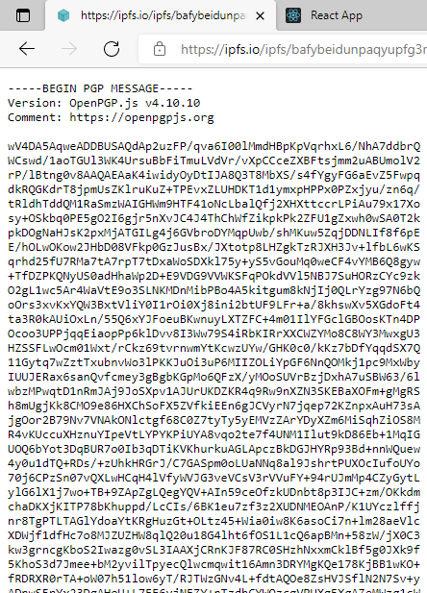

Figure - Encrypted file in IPFS

Since the application wants to prevent unauthorized access to patient’s information, the files stored in IPFS is encrypted and is displayed if access directly in IPFS’ server.

**Content Identifier Explorer**

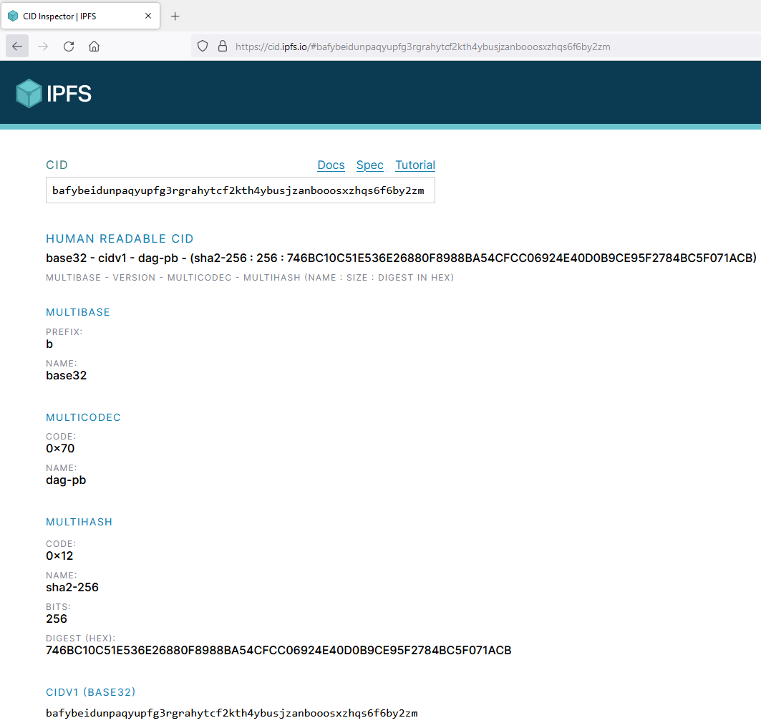

Figure - Content Identifier Breakdown using IPFS CID Explorer

Figure 41 is an illustration of the breakdown of the generated Content Identifier of the uploaded encrypted file from IPFS. This contains details concerned on how the identifier was assembled and what type of hashing algorithm was used. It also has human readable breakdown for easier investigation of its component.

**DAG Visualization**

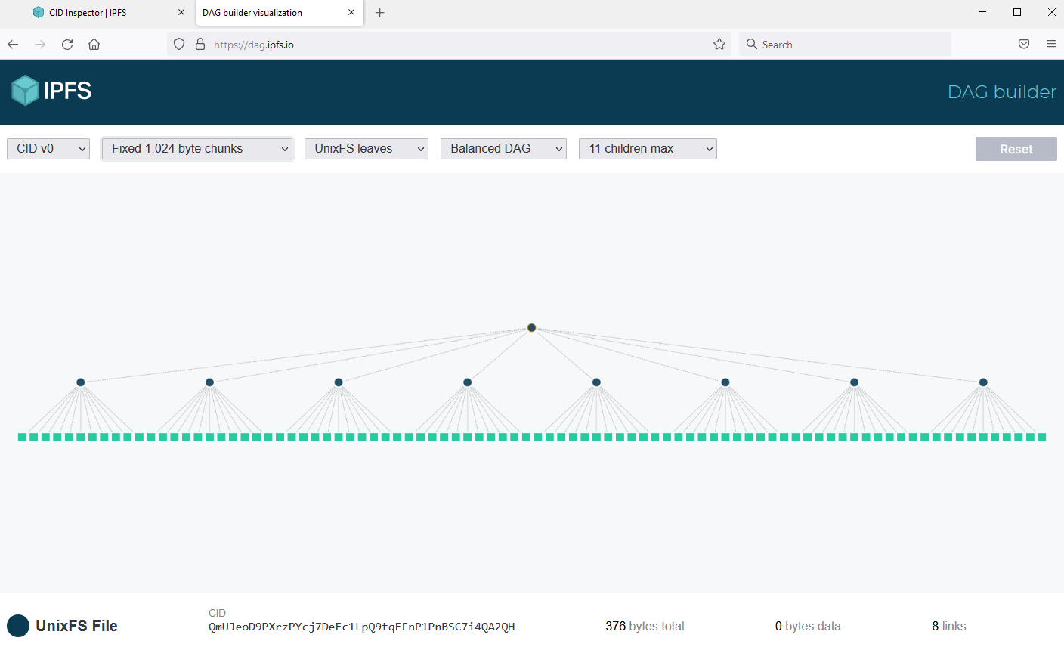

Figure - Merkle DAG Illustration using IPFS DAG Visualizer

Figure 42 shows the generated Merkle DAG of a sample uploaded file. It is chunked in 1,024 (over 1KB) and all nodes has two levels of ancestry.

## **5.4 Data Tampering Results**

1. Tamper summary hash in database

* Update summary hash of a patient ID via database update script
* Scan patient Vaccine QR Code
* Expected Result: App flags the QR code as Invalid.

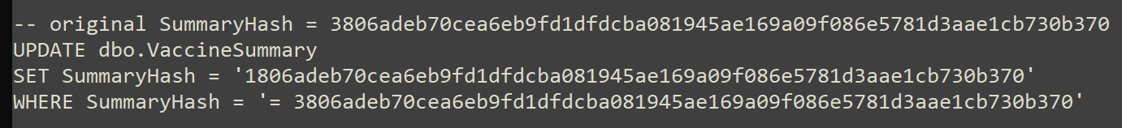Update Script:

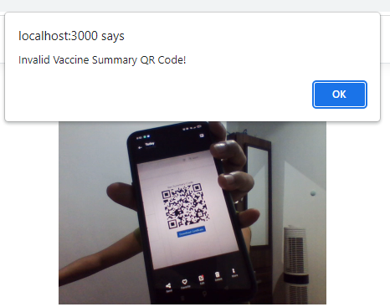UI Result:

Figure 43 - UI Screenshot for invalid Summary QR Code

1. Tamper file hash in database

* Generate a tampered vaccine certificate pdf from an existing file
* Get file hash of tampered data and put it in the database via database update script
* Validate file via “Validate File Upload”
* Expected Result: App flags the uploaded file as Invalid.

|  |  |
| --- | --- |
| Original File  Figure 44 - Original File for Tamper Test | Tampered File  Figure 45 - Tampered File for Tamper Test |

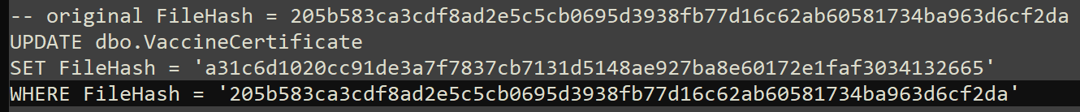Update Script

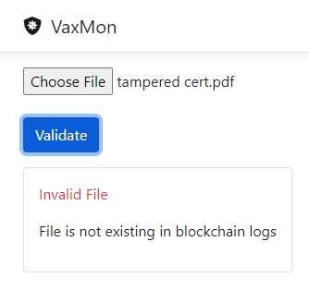UI Result:

Figure - UI Screenshot for Invalid File

The application was able to handle above tampering scenarios which both used database intervention from the attacker.

## **5.5 Security Assessment**

The researcher employed two Solidity scans and a Cybersecurity Assessment to audit the application’s functionality. This ensures that the application complies with existing standard for Solidity and Open Web Applications. Because the application size is small, the scans were focused on the blockchain and web application aspects.

**5.5.1 Smart Contract Weakness Classification Registry**

The Smart Contract Weakness Classification Registry (SWC Registry) is an implementation of the weakness classification scheme proposed in [EIP-1470](https://github.com/ethereum/EIPs/issues/1469). It is loosely aligned to the terminologies and structure used in the Common Weakness Enumeration ([CWE](https://cwe.mitre.org/)) while overlaying a wide range of weakness variants that are specific to smart contracts.

The goals of this project are as follows:

* Provide a straightforward way to classify security issues in smart contract systems.
* Define a common language for describing security issues in smart contract systems' architecture, design, or code.
* Serve as a way to train and increase performance for smart contract security analysis tools.

The chosen scans, Securify and Slither, based their supported vulnerabilities from SWC Registry

**5.5.1.1 Securify**

The Securify tool is a static analyzer tool for Ethereum Solidity contracts. This tool scans the contract code and finds the security vulnerability patterns in the code. After scanning, it generates a report along with descriptions of each vulnerability it has found and provides an idea of how to solve each vulnerability.

**Scan Result**

Table 8 - Securify Scan Result Details

|  |  |  |  |
| --- | --- | --- | --- |
| Item # | Severity | Pattern | Description |
| 1 | Medium | Missing Input Validation | Method arguments must be sanitized before they are used in computations. |
| 2 | Medium | Missing Input Validation | Method arguments must be sanitized before they are used in computations. |
| 3 | Medium | Missing Input Validation | Method arguments must be sanitized before they are used in computations. |
| 4 | Low | Solidity pragma directives | Avoid complex solidity version pragma statements. |

Table 9 - Securify Results Summary

|  |  |
| --- | --- |
| Critical | 0 |
| High | 0 |
| Medium | 3 |
| Low | 1 |
| Informational | 0 |
| Total | 4 |

Table 8 shows a list of all the scan vulnerabilities encountered. There are three redundant entries which were found on different parts of the smart contract code. Table 9 shows a tally of the vulnerabilities based on their severity. All three Medium vulnerabilities fall under “Missing Input Validation - Method arguments must be sanitized before they are used in computation”. The researcher chose to bypass this vulnerability as sanitation is already done on the web browser by using a front-end framework. The update/create transaction in Solidity is also guarded by an authorization modifier, thus only letting known entity to the blockchain make a successful transaction.

The single Low vulnerability is categorized under Solidity pragma directives - Avoid complex solidity version pragma statements. The researcher also skipped this vulnerability as this is not a security threat and more of a namespace convention or best practice. Since the application is still on Proof-of-Concept stage, the pragma versions used was a range to keep an open option when porting the testing from Remix (web) and local blockchain network.

**5.5.1.2 Slither**

Slither is a Solidity static analysis framework written in Python 3. It runs a suite of vulnerability detectors, prints visual information about contract details, and provides an API to easily write custom analyses. Slither enables developers to find vulnerabilities, enhance their code comprehension, and quickly prototype custom analyses.

**Scan Result**

Table 10 - Slither Scan Result Details

|  |  |  |  |
| --- | --- | --- | --- |
| Item # | Severity | Pattern | Description |
| 1 | Informational | Pragma version is too complex | Solidity versions mismatch |

Table 11 - Slither Results Summary

|  |  |
| --- | --- |
| Critical | 0 |
| High | 0 |
| Medium | 0 |
| Low | 0 |
| Informational | 1 |
| Total | 1 |

Table 10 shows the audit items found in the scan. The single vulnerability found is “Pragma version is too complex” and is categorized under “Informational”. This is the same finding as with Securify scan pertaining to pragma version. Table 11 summarizes the scan by severity. It is worth noting that Slither and Securify have audit findings that have the same specifications and criteria such as the item mentioned here. “Pragma version is too complex” is comparable to Securify’s “Solidity pragma directives”.

**5.5.2 NIST – Cybersecurity Framework**

The NIST CSF enables providers to assess their cybersecurity environment, regardless of size, degree of risk, or experience. It also offers voluntary guidance to providers to understand, select, and implement cybersecurity controls.

The researcher focused the assessment on the Protect Core function because this research is specifically concerned with the security aspects of the application. This function provides the framework develop and implement the appropriate safeguards to limit or contain the potential impact of a cybersecurity event.

Table - NIST-CF Maintenance Area Matrix

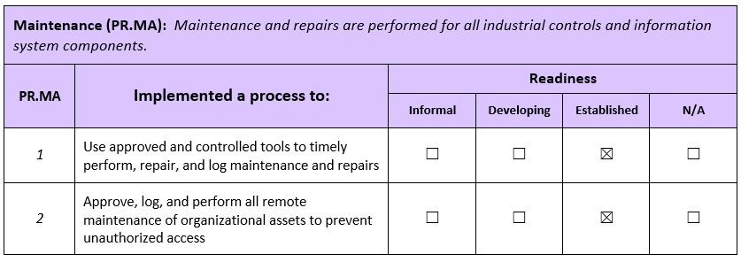

As shown on table 12, both items were established. Item 1 was implemented by using Solidity audit scans on deployed smart contracts. This enables the continuous maintenance of the app if Solidity standards are updated. Item 2 was implemented by using a source control (GIT) to monitor all assets being pushed in the application repository.

Table - NIST-CF Data Security Area Matrix

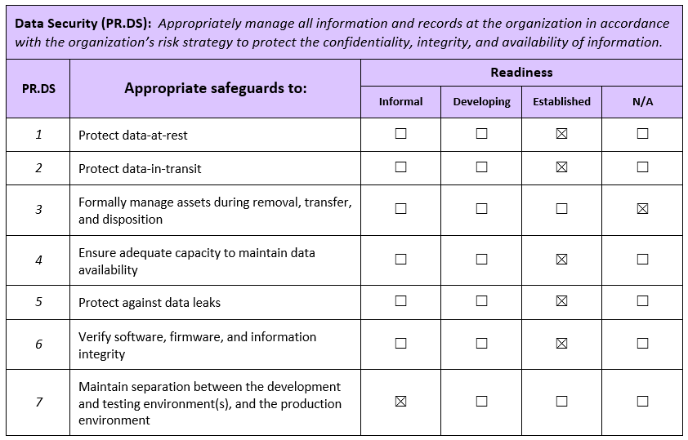

As seen on table 13, items pertaining to Confidentiality of the Information (protect data-at-rest, protect data-in-transit, ensure adequate capacity, protect against data leaks and verify software) were established. These were implemented by various measures such as file encryption/decryption, appropriate package upgrades using plugin managers and usage of Proof-of-Authority to manage downtime and performance. However, item 3 is not applicable to the system because of the prototyping nature of the application. Item 7 is informally implemented because the environment of the application prototype persists on virtual sandboxes. This type of environment is used for testing purposes only.

Table - NIST-CF Protective Technology Area Matrix

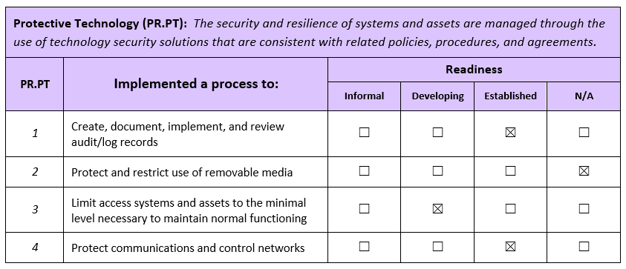

On table 14, items 1 and 4 are established. Item 1 was implemented by logging all errors in the database and organizing them to be easily sorted and recognized. This also includes application and event logs on server side. Item 4 was executed by the segregated architecture of the application to separate communications between frontend, business logic and data layer. This enables decoupling of responsibilities among these components. Item 3 is developing because of the limited scope of the application. This requires more information to the level of data users can access within their persona. Finally, item 2 is not applicable to the system because it does not have media components

## **5.6 Performance Test**

The researcher used JMeter tool to conduct the load tests. A sample of 20 concurrent users were identified as test data for the 3 main functionality of the application

1. Create Vaccine Record

Table 15 - Create Vaccine Record Load Test Result

|  |  |  |  |
| --- | --- | --- | --- |
| Run # | No. of Concurrent Users | Response Time (seconds) | No. of PoA Nodes |
| 1 | 20 | 121 | 5 |
| 2 | 20 | 113 | 5 |
| 3 | 20 | 99 | 5 |
| 4 | 20 | 134 | 5 |
| 5 | 20 | 118 | 5 |
|  | Average | 117 |  |

* This transaction involves file creation, IPFS upload and writing to the blockchain. It is important to note that writing to the blockchain is slow. This is because it has to sync-up with all the validator nodes and update all the logs within those nodes.

1. Validate Vaccine QR Code

Table 16 - Validate Vaccine QR Code Load Test Result

|  |  |  |  |
| --- | --- | --- | --- |
| Run # | No. of Concurrent Users | Response Time (seconds) | No. of PoA Nodes |
| 1 | 20 | 7 | 5 |
| 2 | 20 | 7 | 5 |
| 3 | 20 | 8 | 5 |
| 4 | 20 | 5 | 5 |
| 5 | 20 | 9 | 5 |
|  | Average | 7.2 |  |

* This transaction includes scanning of QR code and reading from the blockchain. As compared with item a, reading from the blockchain is fast. It only needs to read from the first node that gives a response to the web3 request.

1. Validate Vaccine File

Table 17 - Validate Vaccine File Load Test Result

|  |  |  |  |
| --- | --- | --- | --- |
| Run # | No. of Concurrent Users | Response Time (seconds) | No. of PoA Nodes |
| 1 | 20 | 10 | 5 |
| 2 | 20 | 8 | 5 |
| 3 | 20 | 9 | 5 |
| 4 | 20 | 10 | 5 |
| 5 | 20 | 10 | 5 |
|  | Average | 9.4 |  |

* Same as item b, this also reads from the blockchain. The additional process is generating a filehash from the uploaded file which concurred additional response time.

**Chapter Six**

# **CONCLUSIONS AND RECOMMENDATIONS**

This section contains the discussions of the conclusions and researcher recommendations based on the results of the study.

**Conclusions**

Based on the stated objectives of the study, the researcher concludes the following:

1. Application was able to implement Proof-of-Authority blockchain (which natively uses Keccak Hash Algorithm to process transactional blocks) to store vaccine records. Other blockchain-related technologies were used such as: Solidity (smart contract), web3 and Geth.
2. Application was able to implement Merkle DAG by using native functionalities of IPFS. Data storage was illustrated by various IPFS tools (CID Explorer, IPFS file server). Specifically, the generated hash tree for a sample vaccine certificate file can be reproduced by IPFS DAG Visualizer.
3. The researcher was able to assess the vulnerabilities flagged by the scans and made efforts to eliminate and lessen the weaknesses for blockchain transactions via Smart Contract Weakness Classification Registry (SWC Registry). Accomplishment of NIST-CF Protect Core Function, specifically Maintenance, Data Security and Protective Technology, was also done to ensure the system complies with existing standards for Cyber Security. The researcher listed out areas already handled by the native functionality of the system and excluded items that are not applicable given the nature of the application.

**Recommendations**

This study recommends the use of blockchain in keeping medical records as it provides the following benefits:

1. Blockchain-based electronic health records gives medical personnel control over the flow of information from a single, trusted platform.
2. Eliminates the need to have multiple system to consolidate other transactions as blockchain can handle and validate different types of transaction logs.
3. When used with IPFS, provides a better file storage implementation for systems that need file upkeeps.

Further development and enhancement of the system is thereby recommended to future researchers, especially to include the following:

1. Future work can look into integrating the other phases of vaccination such as scheduling or vaccine management.
2. The potentiality of processing large quantities of blockchain data makes it promising to use Artificial Intelligence to provide insights and reports.
3. Since the application is web-based and creates a web-responsive viewport to mobile users, it is a good addition to create a dedicated mobile application to patients to enhance their user experience.

# **REFERENCES**

Abadi, Joseph and Brunnermeier, Markus (2018). *Blockchain Economics*

Al Asad, Nafiz; Elahi, Md. Tausif; Al Hasan, Abdullah; Yousuf, Mohammad Abu (2020). *Permission-Based Blockchain with Proof of Authority for Secured Healthcare Data Sharing*

Azaria, Asaph; Ekblaw, Ariel; Vieira, Thiago; Lippman, Andrew (2016). *MedRec: Using Blockchain for Medical Data Access and Permission Management*

Baumgart, Ingmar and Mies, Sebastian (2007). *S/kademlia:* *A practicable approach towards secure key-based routing.*

Bellare, Mihir; Desai Anand; Pointcheval, David; Rogaway, Phillip (1998). *Relations among notions of security for public-key encryption schemes*

Benet, Juan (2014). *IPFS - content addressed, versioned, P2P file system (draft 3)*

Bertoni, Guido; Daemen, Joan; Peeters, Michael; Van Assche, Gilles (2013). *Keccak*

Bojanova, Irena and Voas, Jeffrey (2014). *NIST: Building a Solid Foundation*

De Angelis, Stefano; Aniello, Leonardo; Baldoni, Roberto; Lombardi, Federico; Margheri, Andrea; Sassone, Vladimiro (2018). *PBFT vs proof-of-authority: applying the CAP theorem to permissioned blockchain*

Ebardo, Ryan and Celis, Nelson (2019). *Barriers to the Adoption of Electronic Medical Records in Select Philippine Hospitals: A Case Study Approach*

Ebardo, Ryan and Tuazon, John Byron (2019). *Identifying Healthcare Information Systems Enablers in a Developing Economy*

Falco, Joseph; Gilsinn, James; Stouffer, Keith (2004). *IT Security for Industrial Control Systems:Requirements Specification and Performance Testing*

Freedman, Michael J.; Freudenthal, Eric; Mazieres, David (2004). *Democratizing content publication with Coral*

Fujisaki, Eiichiro and Okamoto, Tatsuaki (2011). *Secure Integration of Asymmetric and Symmetric Encryption Schemes*

Garzik, Jeff (2015). *Public versus Private Blockchains*

Gesulga, Jaillah Mae; Berjame, Almarie; Moquiala, Kristelle Sheen; Galido, Adrian (2017). *Barriers to Electronic Health Record System Implementation and Information Systems Resources: A Structured Review*

Gilbert, Henri and Handschuh, Helena (2004). *Security Analysis of SHA-256 and Sisters*

Goldwasser, Shafi and Micali, Silvio (1984). *Probabilistic encryption*

Huang, Jing; Zhou, Kuo; Xiong, Ao; Li Dongmeng, 2022. *Smart Contract Vulnerability Detection Model Based on Multi-Task Learning*

Khalifa, Mohamed (2018). *Perceived Benefits of Implementing and Using Hospital Information Systems and Electronic Medical Records*

Khubrani, Mousa Mohammed (2021). *A Framework for Blockchain-based Smart Health System*

Kumar, Randhir and Tripathi, Rakesh (2020). *A Secure and Distributed Framework for sharing COVID-19 patient Reports using Consortium Blockchain and IPFS*

Kumar, Shivansh; Bharti, Aman Kumar; Amin, Ruhul (2021). *Decentralized secure storage of medical records using Blockchain and IPFS: A comparative analysis with future directions*

Maymounkov, Petar and Mazieres, David (2002). *Kademlia: A peer-to-peer information system based on the xor metric*

Menezes, Alfred; van Oorschot, Paul; Vanstone, Scott (1997). *Handbook of Applied Cryptography*

Merkle, Ralph (1989). *A Certified Digital Signature*

Micali, Silvio; Jakobsson, Markus; Leighton, Tom; Szydlo, Michael (2003). *Fractal merkle tree representation and traversal.*

Monrat, Ahmed Afif; Schelén, Olov; Andersson, Karl (2019). *A Survey of Blockchain From the Perspectives of Applications, Challenges, and Opportunities*

Nakov, Svetlin (2018). *Practical Cryptography for Developers*

National Institute of Standards and Technology (2002). *FIPS-180-2:* *Secure Hash Standard (SHS)*

Rameder, Heidelinde; di Angelo, Monika; Salzer, Gernot (2022). *Review of Automated Vulnerability Analysis of Smart Contracts on Ethereum*

Radziwill, Nicole and Benton, Morgan (2017). *Cybersecurity Cost of Quality: Managing the Costs of Cybersecurity Risk Management*

Reen, Gaganjeet (2019). *Decentralized Patient Centric e-Health Record Management System using Blockchain and IPFS*

Sharma, Saurabh; Mishra, Ashish; Lala, Ajay; Singhai, Deeksha (2020). *Secure Cloud Storage Architecture for Digital Medical Record in Cloud Environment using Blockchain*

Sklavos, Nicolas and Koufopavlou, Odysseas G. (2003). *On the hardware implementation of the SHA-2 (256, 384, 512) Hash functions*

Sukrutha, V. and Latha, Y. Madhavi (2013). *Securing the Web using Keccak (SHA-3)*

Sun, Jin; Yao, Xiaomin; Wang, Shangping; Wu, Ying (2020). *Blockchain-based secure storage and access scheme for electronic medical records in IPFS*

Szabo, Nick (1997). *Smart contracts: formalizing and securing relationships on public networks.*

Szydlo, Michael (2003). *Merkle tree traversal in log space and time*

Tsai, Jack and Bond, Gary (2007). *A comparison of electronic records to paper records in mental health centers*

Vujičić, Dejan; Jagodić, Dijana; Ranđić, Siniša (2018). *Blockchain Technology, Bitcoin, and Ethereum: A Brief Overview*

Wu, Sihua and Du, Jiang (2019). *Electronic medical record security sharing model based on blockchain*

Xie, Ming (2003). *P2P Systems based on Distributed Hash Table*

Yaga, Dylan; Mell, Peter; Roby, Nik; Scarfone, Karen (2018). *Blockchain Technology Overview*

Yoshida, Hirotaka and Biryukov, Alex (2005). *Analysis of a SHA-256 Variant*

Zheng, Zibin; Xie, Shaoan; Dai, Hong-Ning; Chen, Xiangping (2017). *An Overview of Blockchain Technology: Architecture, Consensus, and Future Trends*

# **APPENDICES**

**Generated Vaccine Certificate**

**Solidity Code to Manage Hash Lookups**

// SPDX-License-Identifier: GPL-3.0

**pragma** solidity >=0.5.0 <0.9.0;

**contract** Certificate {

**mapping** (**string** => **uint256**) fileHashUserId;

**mapping** (**string** => **uint256**) summaryHashUserId;

**function** isFileHashUserIdExists(**string** **memory** _fileHash, **uint256** _userId)

**public** **view** **returns**(**bool**)

{

**if** (fileHashUserId[_fileHash] == _userId) {

**return** **true**;

}

**return** **false**;

}

**function** saveUserIdHashes(**string** **memory** _fileHash, **string** **memory** _summaryHash, **uint256** _userId)

**public**

{

summaryHashUserId[_summaryHash] = _userId;

fileHashUserId[_fileHash] = _userId;

}

**function** isSummaryHashUserIdExists(**string** **memory** _summaryHash, **uint256** _userId)

**public** **view** **returns**(**bool**)

{

**if** (summaryHashUserId[_summaryHash] == _userId) {

**return** **true**;

}

**return** **false**;

}

}

**Source Code**

import { useState, useEffect } from "react";

import getWeb3 from "../getWeb3";

import truffleContract from "truffle-contract";

import detectEthereumProvider from '@metamask/detect-provider'

import CertificateContract from "../contracts/Certificate.json"

import VaxForm from "./VaxForm";

import ScanPatientId from "./ScanPatientId";

const CertificateUpload = () => {

const [vaxDetails, setVaxDetails] = useState({

patientId: null,

firstName: '',

lastName: '',

email: '',

address: '',

birthdate: '',

doses: {}

});

const {patientId} = vaxDetails;

const [ethState, setEthState] = useState({

web3: null,

accounts: null,

contract: null,

});

useEffect(() => {

const initWeb3 = async () => {

try {

const web3 = await getWeb3();

const accounts = await web3.eth.getAccounts();

const provider = await detectEthereumProvider()

if (!provider) {

console.log('Please install metamask!');

return;

}

const contract = truffleContract(CertificateContract);

contract.setProvider(provider);

const instance = await contract.deployed();

setEthState({ ...ethState, accounts: accounts, contract: instance });

} catch (error) {

alert(`Failed to load web3, accounts, or contract. Check console for details.`);

console.log(error);

}

}

initWeb3();

}, []);

const sendToBlockchain = async (fileHash, summaryHash) => {

const contract = ethState.contract;

const account = ethState.accounts[0];

await contract.saveUserIdHashes(fileHash, summaryHash, patientId, { from: account });

alert('data sent to blockchain');

}

const manualSendToBc = async () => {

const fileHash = '3a206c85ccf6a92931276f1eb10882069e868413aff3694761a8ee675dd50034'

const summaryHash = '1060832ae769ce5d899a5b1ecda4f9304d80d49b81f6d4f3e22fdcca5e9c040e'

await sendToBlockchain(fileHash, summaryHash);

}

const checkFileHash = async () => {

const fileHash = '3a206c85ccf6a92931276f1eb10882069e868413aff3694761a8ee675dd50034';

const contract = ethState.contract;

const account = ethState.accounts[0];

const isExists = await contract.isFileHashUserIdExists(fileHash, patientId, { from: account });

alert(`fileHash - ${fileHash} - ${isExists}`);

}

const sendDataToParent = (doseType, data) => {

const doses = JSON.parse(JSON.stringify(vaxDetails.doses));

doses[doseType] = data;

setVaxDetails({ ...vaxDetails, doses: doses });

};

const handlePatientDetails = (details) => {

setVaxDetails({

...vaxDetails,

patientId: details.patientId,

firstName: details.firstName,

lastName: details.lastName,

email: details.email,

address: details.address,

birthdate: details.birthdate

});

};

const submitRecord = async (e) => {

e.preventDefault();

e.target.reset();

const requestOptions = {

method: 'POST',

headers: { 'Content-Type': 'application/json' },

body: JSON.stringify(vaxDetails)

};

const response = await fetch('api/create-vaccine-record', requestOptions);

const data = await response.json();

const fileHash = data.fileHash;

const summaryHash = data.summaryHash;

console.log('data', data);

await sendToBlockchain(fileHash, summaryHash);

}

if (!ethState.contract) {

return <div>Loading Web3, accounts, and contract...</div>;

}

return (

<div className="d-flex justify-content-around">

<div>

<ScanPatientId handlePatientDetails={handlePatientDetails}></ScanPatientId>

</div>

<form onSubmit={submitRecord} className="w-50 d-flex flex-column" style={{maxWidth:'500px'}}>

{patientId == null && <p className="text-danger">Please scan a Patient QR Code first.</p>}

<VaxForm title={'Dose 1'} doseType={'dose1'} sendDataToParent={sendDataToParent}></VaxForm>

<VaxForm title={'Dose 2'} doseType={'dose2'} sendDataToParent={sendDataToParent}></VaxForm>

<br/>

<div>

<button disabled={patientId == null} type="submit" className="btn btn-primary w-50">Submit</button>

</div>

</form>

</div>

);

}

export default CertificateUpload;

import React from 'react';

import { useState, useEffect } from "react";

import SummaryView from "../SummaryView";

import SummaryDoses from "../SummaryDoses";

import getWeb3 from "../../getWeb3";

import truffleContract from "truffle-contract";

import detectEthereumProvider from '@metamask/detect-provider'

import CertificateContract from "../../contracts/Certificate.json"

import QrReader from 'react-qr-scanner'

const SummaryValidate = () => {

const previewStyle = {

height: 240,

width: 320,

}

const delay = 100;

const [ethState, setEthState] = useState({

web3: null,

accounts: null,

contract: null,

});

const [isValidate, setIsValidate] = useState(false);

const [details, setDetails] = useState({

firstName: "",

lastName: "",

address: "",

summary: null,

userId: null

});

const {summary} = details;

useEffect(() => {

if (window.location.href.indexOf("validate/summary-code") !== -1) {

setIsValidate(true);

}

const initWeb3 = async () => {

try {

const web3 = await getWeb3();

const accounts = await web3.eth.getAccounts();

const provider = await detectEthereumProvider()

if (!provider) {

console.log('Please install metamask!');

return;

}

const contract = truffleContract(CertificateContract);

contract.setProvider(provider);

const instance = await contract.deployed();

setEthState({ ...ethState, accounts: accounts, contract: instance });

} catch (error) {

alert(`Failed to load web3, accounts, or contract. Check console for details.`);

console.log(error);

}

}

initWeb3();

}, []);

const handleScan = async (data) => {

if (!data) return;

let summaryHash = null;

try {

summaryHash = data['text'];

} catch {

alert('Invalid QR Code');

return;

}

const summaryData = await fetchData(summaryHash);

if (!summaryData)

return;

console.log('data', summaryData);

const isExistInBc = await checkSummaryHash(summaryHash, summaryData.UserId);

if (isExistInBc) {

console.log('exists in bc')

setDetails({

...details,

firstName: summaryData.FirstName,

lastName: summaryData.LastName,

address: summaryData.Address,

summary: !!summaryData ? JSON.parse(summaryData.Summary) : null

});

}

}

const handleError = (err) => {

console.log('qr scan error', err);

}

const fetchData = async (summaryHash) => {

const url = `/api/summary/${summaryHash}`;

const response = await fetch(url);

const data = await response.json();

return data;

}

const checkSummaryHash = async (summaryHash, userId) => {

const contract = ethState.contract;

const account = ethState.accounts[0];

const isExists = await contract.isSummaryHashUserIdExists(summaryHash, userId, { from: account });

return isExists;

}

if (!ethState.contract) {

return <div>Loading Web3, accounts, and contract...</div>;

}

return (

<div class="d-flex justify-content-center">

<div>

<h5>Scan Summary QR Code</h5>

<QrReader

delay={delay}

style={previewStyle}

onError={handleError}

onScan={handleScan}

/>

</div>

{

!!summary &&

<div class="d-flex">

<div className="card mx-5">

<div className="card-body">

<SummaryView isValidate={isValidate} details={details}></SummaryView>

</div>

</div>

<div className="card m-3">

<div className="card-body">

<SummaryDoses summary={summary}></SummaryDoses>

</div>

</div>

</div>

}

</div>

);

}

export default SummaryValidate;

import { useState, useEffect } from "react";

import getWeb3 from "../getWeb3";

import truffleContract from "truffle-contract";

import detectEthereumProvider from '@metamask/detect-provider'

import CertificateContract from "../contracts/Certificate.json"

import VaxForm from "./VaxForm";

import ScanPatientId from "./ScanPatientId";

const CertificateUpload = () => {

const [vaxDetails, setVaxDetails] = useState({

patientId: null,

firstName: '',

lastName: '',

email: '',

address: '',

birthdate: '',

doses: {}

});

const {patientId} = vaxDetails;

const [ethState, setEthState] = useState({

web3: null,

accounts: null,

contract: null,

});

useEffect(() => {

const initWeb3 = async () => {

try {

const web3 = await getWeb3();

const accounts = await web3.eth.getAccounts();

const provider = await detectEthereumProvider()

if (!provider) {

console.log('Please install metamask!');

return;

}

const contract = truffleContract(CertificateContract);

contract.setProvider(provider);

const instance = await contract.deployed();

setEthState({ ...ethState, accounts: accounts, contract: instance });

} catch (error) {

alert(`Failed to load web3, accounts, or contract. Check console for details.`);

console.log(error);

}

}

initWeb3();

}, []);

const sendToBlockchain = async (fileHash, summaryHash) => {

const contract = ethState.contract;

const account = ethState.accounts[0];

await contract.saveUserIdHashes(fileHash, summaryHash, patientId, { from: account });

alert('data sent to blockchain');

}

const manualSendToBc = async () => {

const fileHash = '3a206c85ccf6a92931276f1eb10882069e868413aff3694761a8ee675dd50034'

const summaryHash = '1060832ae769ce5d899a5b1ecda4f9304d80d49b81f6d4f3e22fdcca5e9c040e'

await sendToBlockchain(fileHash, summaryHash);

}

const checkFileHash = async () => {

const fileHash = '3a206c85ccf6a92931276f1eb10882069e868413aff3694761a8ee675dd50034';

const contract = ethState.contract;

const account = ethState.accounts[0];

const isExists = await contract.isFileHashUserIdExists(fileHash, patientId, { from: account });

alert(`fileHash - ${fileHash} - ${isExists}`);

}

const sendDataToParent = (doseType, data) => {

const doses = JSON.parse(JSON.stringify(vaxDetails.doses));

doses[doseType] = data;

setVaxDetails({ ...vaxDetails, doses: doses });

};

const handlePatientDetails = (details) => {

setVaxDetails({

...vaxDetails,

patientId: details.patientId,

firstName: details.firstName,

lastName: details.lastName,

email: details.email,

address: details.address,

birthdate: details.birthdate

});

};

const submitRecord = async (e) => {

e.preventDefault();

e.target.reset();

const requestOptions = {

method: 'POST',

headers: { 'Content-Type': 'application/json' },

body: JSON.stringify(vaxDetails)

};

const response = await fetch('api/create-vaccine-record', requestOptions);

const data = await response.json();

const fileHash = data.fileHash;

const summaryHash = data.summaryHash;

console.log('data', data);

await sendToBlockchain(fileHash, summaryHash);

}

if (!ethState.contract) {

return <div>Loading Web3, accounts, and contract...</div>;

}

return (

<div className="d-flex justify-content-around">

<div>

<ScanPatientId handlePatientDetails={handlePatientDetails}></ScanPatientId>

</div>

<form onSubmit={submitRecord} className="w-50 d-flex flex-column" style={{maxWidth:'500px'}}>

{patientId == null && <p className="text-danger">Please scan a Patient QR Code first.</p>}

<VaxForm title={'Dose 1'} doseType={'dose1'} sendDataToParent={sendDataToParent}></VaxForm>

<VaxForm title={'Dose 2'} doseType={'dose2'} sendDataToParent={sendDataToParent}></VaxForm>

<br/>

<div>

<button disabled={patientId == null} type="submit" className="btn btn-primary w-50">Submit</button>

</div>

</form>

</div>

);

}

export default CertificateUpload;